Introduction:

This model simulates the voting turnout of a set two-party population through constant polling. The results of the election are not as important as the number of total voters. The model explores how this number varies based on the information a voter has on the potential outcome of an election and the uncertainty associated with this information.

Rationale:
We chose to base this model on one of Professor Diermeier's theses. He hypothesized and proved that in a given population consisting of two parties, voting turnout will be low when given perfect sample information. In addition, when moderate polling noise is present, turnout will increase. However, when excessive noise is present, turnout will rapidly decrease and eventually become zero.

Because we found this behavior very interesting and not overtly intuitive, we decided to model it. We will discuss how this behavior emerges given the rules of the model further in the “Discussion and Analysis” section below.

How it works:

There are 100 people who are either Democrats or Republicans (blue vs red). Each voter has his own payoff matrix, where if his party wins he receives a benefit of 1. If the election results in a tie, the benefit is 1/2. However, there is a cost (denoted C) to vote. The net benefit to vote is payoff minus cost (B-C). Thus, a voter will only vote if his cost is less than the probability that his vote will make a difference times benefit (in this model it is 1) divided by 2 (to account for a tie).

Out of the initial number of Democrats and Republicans, a set percentage of each group has initially decided to vote (selected by slider).

At each turn, each individual will poll a certain number (sample size) randomly from the population and count the number of voters who are Democrats or Republican. The individual then performs a cost-benefit analysis to determine whether or not to vote.
When noise is factored in, the person becomes uncertain to a certain degree (denoted by noise) about the validity of his polling results. It is favorable to vote when the perceived results show that Democrats and Republicans are tied or if the individual's party is losing by 1 vote. When noise is incorporated, an individual will determine the probability that his vote will end up in a favorable outcome. This is calculated by stepping through each possible outcome and summing the favorable ones and then dividing by the total number of possibilities. This probability is then multiplied by 1/2 (benefit accounting for tie) to determine the net benefit.

To summarize, the rules of the model are as follows:
- A voter takes a random sample of voters in the population and sums the number of voters in each of the two parties.
- She then factors noise (which can be anywhere from noiseless to +- 20) into her perceived voter totals and finds the probability that her vote counts. Favorable voting conditions occur when her party is tied with or losing by a single vote to the rival party.
- If this probability multiplied by the benefit of tying the election is greater than the cost of voting, she will vote.

So, in order to set up the model:
- Specify the amount of the population that is Republican.
- Set the initial number of voters voting in each party (you will see that this has no effect on turnout).
- Choose a cost of voting and noise level (0 noise is a good place to start, so that you can increase noise to see how turnout changes).

Discussion and analysis:

When running the model, you should be able to see that moderate noise leads to many voters. Why does this occur?

Let’s try an example. Suppose you are a Democrat and you sample 8 random people. Of those people, 2 are voting Republican and 2 are voting Democrat. Generally speaking, a voter will vote only when it’s perceived that the result of an election is a tie or party win. So, in the noiseless model, you would see this:

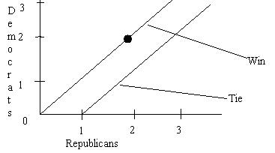
You are on the win line, so you would vote. Now, with a noise level of one, and the same conditions as above, you would see the situation this way:

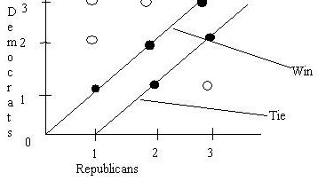
As you can see, with a noise level of 1, there could be 3 Republican Voters and 1 Democrat voter, 1 Republican voter and 3 Democrat voters, 3 of each, 2 of each, 1 of each, and all other combinations of 2 plus or minus 1 Democrats and 2 plus or minus 1 Republicans. Notice that there are 9 possibilities for the outcome of the election and that 5 of them are favorable. So, the probability that your vote counts is 5/9, and the benefit from winning the election is this probability multiplied by the benefit, 1. Since you have to account for a tie, you will vote if this benefit probability divided by 2 is greater than your cost.

The result of all of this is that as noise levels increase, there are more combinations of Democrat and Republican voters that yield non-zero probabilities. So, at moderate noise levels, we see that these probabilities outweigh the cost of voting. However, as the noise increases to higher levels, the probabilities become very small, and the cost of voting takes over.

The main determinants of how high the turnout can go are cost and sample size. At lower costs and at lower sample sizes, turnout increases. This makes sense, because low costs means there’s more incentive to vote, and at higher samples, the perceived turnout is a more accurate portrayal of the actual election.

To demonstrate this, pick values of sample size and cost to be 10 and 0.08 respectively. Start at noise level 0 and increment it until you reach 11. You should see a graph like this:

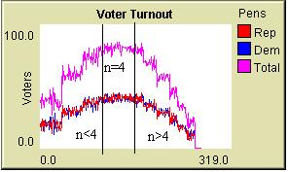

There is a maximum voter turnout around 90 at a noise level of 4. You can see the emergent behavior of increased turnout at moderate noise. In this case, the sample size and costs are relatively low, and we see an extremely high maximum turnout.

Now, let’s look at a high cost model. Here, the cost is 0.13:

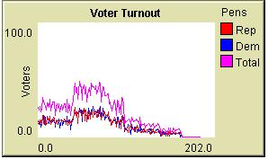

The maximum voter turnout, about 50 percent, occurs around a level of 2 or 3. This makes sense, because the cost at higher noise levels quickly becomes greater than the probability that a vote will make a difference. It is important to notice that a high cost affects both the value of the maximum and the noise level. In this case a noise level of 4 is no longer optimal.

Finally, let’s look at a large sample, 40% and 0.08 cost:

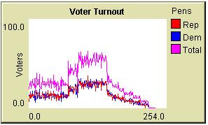

Here, the maximum turnout is about 60% and occurs at noise levels of 3 and 4. We again see dampened turnout, because as noted above, the information more accurately reflects the actual turnout. Also, since negative scenarios (we can’t have -2 Democrat voters, for example) are not taken into account in the probability calculation, there are more possibilities taken into account at larger samples. So, it makes sense that turnout overall is lower when sample sizes are larger.

Finally, you’ll notice that there is a button titled poll-at-once? in this model. This is somewhat experimental, because it looks at the voters all polling at the same time, as opposed to sequentially (which more accurately reflects an asynchronous polling model). If in a population everyone decided to poll at a certain time on a certain day, we might the behavior exhibited by this option. When selected, voters vote in waves. At each tick, the turnout fluctuates between very low or zero turnout and very high or 100% turnout.

In conclusion, the theory that moderately imperfect information leads to higher voter turnout holds. We can clearly see a difference when uncertainty is increased, and compare it to a scenario where everyone knows what everyone else is doing. The difference is significant and we invite you to explore the model with any scenarios you’d like to see.

Extending the Model:

You could try having each individual only poll his neighbors instead of random people.

You could implement several polling methods and combine them. These could be polling neighbors, random people, and polls heard on television/radio.

You could make it possible for a democratic supporter to turn into a republican supporter and vice versa.

Related Models:

There is a basic Voting model that exists in the models library that one could refer to.

Credits and References:

Created by Eric Cheng and Mazen Al-Khaleefa.

Original model design by Professor Diermeir (Kellogg School of Management).

http://pubweb.nwu.edu/~ewc142/our model so we can show it to you.

