Connected Chemistry
Table of Contents

Chapter 1: Gas Laws page

Activity 1
- Everyday Objects 2
- Homework 4

Activity 2
- Modeling A Tire 7
- Homework 11

Activity 3
- Changing Pressure 15
- Homework 18

Activity 4
- Experimenting with Particles 23
- Homework 29

Activity 5
- Number and Pressure 30
- Homework 35

Activity 6
- Temperature and Pressure 38
- Homework 46

Activity 7
- Real World Volume Changes 52
- Homework 57

Activity 8
- Ideal Gas Law 63
- Homework 68

Activity 9
- Modeling Real World Systems 73
- Homework 66

Activity 10
- Ideal Gas Law Applications 80

Investigation Set 1 – Behavior of Gases

Activity 1 –Everyday Objects

Exploration 1:
- When a tire is full of air, it is said to be inflated. When a tire has less air in it then it needs to operate it is said to be deflated. Study the deflated bike tire and air pump shown in the classroom.

Question #1 When you use an air pump to inflate a tire, it adds air to it.
Draw a picture or model that explains how the air pump inflates the tire:

Exploration 2:
- Use an air filled, sealed syringe:
  - Try to press down on the syringe as hard as you can
  - Record how far you can press the syringe down.
  - Give your lab partner a turn as well.
  - Record how far your lab partner can press the syringe down.
  - Calculate the average for three trials for each of you.

 | Lab partner: | Me:
Trial #1
Trial #2
Trail #3
Average:

Activity 1 –Everyday Objects

Question #2 Were either you or your partner able to push the plunger of syringe all the way in, until it touched the bottom of the syringe? ______________________

Question #3 Why?

_______________________________________________________________________________________________________________________________________________________________________________________________________________________________________________

Exploration 3:
- Observe what happens to the collapsing can after it is heated, flipped upside down, and dunked into cold water.

Question #3 What might be causing the can to collapse and what would help it collapse quicker? Write down a list of ideas that you come up with as a class:

Activity 1 – Homework

Here are a set of objects that rely on the behavior of gases to operate:

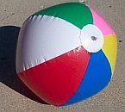 | 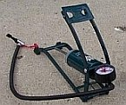 | 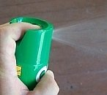

A thorough understanding of how gases behave in one of these objects can help you understand how all these devices work and predict how changes to the objects or in the surroundings would affect their behavior.

Question #1 What are some other common objects that rely on the behavior of gases to operate?
________________________________________________________________________________________________________________________________________________________________________________________________________________________________________________

In the next investigations you will investigate the behavior of the gases bike tire at the macroscopic (what you can see) and microscopic level (at a molecular level).

Let us begin the exploration of what is happening to a gas by studying a common object that contains gas – a bike tire.

In the next two investigations, you will be discovering what happens when air is added into a bicycle tire. When a tire is full of air, it is said to be inflated. When a tire has less air in it then it needs to operate it is said to be deflated.  Question #2 What are ways you can observe or measure whether a tire is inflated?  __________________________________________ | 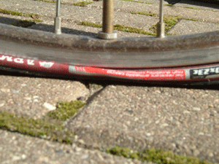
________________________________________________________________________________________________________________________________________________________________________________________________________________________________________________________________________________________________________________________________

Activity 1 – Homework

If you cut open a bike tire you will see that it has a thin inner tub. This inner tube is similar to a balloon except that it also has a valve on it to let air in when it is pumped up.
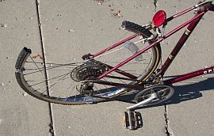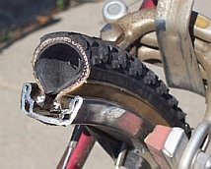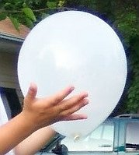

Question 3: What evidence would support the claim that,
“there is gas inside the balloon and the bike tire”

________________________________________________________________________________________________________________________________________________________________________________________________________________________________________________________________________________________________________________________________

Question 4: Gases are one of three common states of matter for substances found in our world. Liquids and solids are the other two. Consider a common substance – water. In the spaces below, draw pictures that provide a model that explains/shows what is different about these three states of matter for water on a microscopic level. Also create a key to show how you are representing the particles and the speed of the particles.

Solid water (ice) | Liquid water | Gaseous water (water vapor)

Activity 1 – Homework

Certain types of observations of how the balloon and bike tire perform may help provide evidence about whether they are filled with gases. But claiming that an object is filled with a gas, does not fully explain how and why the objects function they way they do. Understanding the behavior of gases is necessary for a more complete explanation.

To understand the behavior of the gas, it is important to understand how molecules behave in gases.

Because molecules are extremely small and not visible to our eyes without a microscope, we will build a model to help us visualize and understand how the molecules behave in different situations.

Think about how this spray can relies on the behavior of gas molecules to operate effectively.

Question 5: Draw a model of what is happening in the spray can shown above, that would help explain why spray is coming out of the can.

Activity 2 – Modeling A Tire

In a real bicycle tire you cannot see the air molecules. They are too small to see with only your eyes. You will use a NetLogo computer model to simulate and visualize the molecules inside the bicycle tire as it is being pumped up with air. NetLogo is a free programmable environment for building and running scientific models that simulate natural and social phenomena (available at http://ccl.northwestern.edu/netlogo).

A scientific model is a representation of a system. Some scientific models represent systems that involve processes that can’t be observed directly (e.g. they happen too slowly or quickly or are too large or small or are potentially dangerous). Scientific models are often based upon a set of assumptions that are much simpler or more exaggerated than what actually may be taking place. Let us see examples of the simplifications that you will be using in the NetLogo computer model:

For example, in a bike tire there are often other parts beside the tire wall and the air inside (such as the rim and the inner tube). If you drew a picture of the inside of the bike tire in the photo to the right, you might draw the wall of the bike tire as an uneven circle, oval, or teardrop shape.

In this picture to the right, the bike tire is represented as a yellow box. Although a real bike tire is not box shaped, the yellow box is a simplified model of the walls of the bike tire. This box helps us clearly see what area is inside the bike tire and what area is outside the bike tire. It will also help us see how the air molecules (not shown here) behave. | 

The model you will be using in the remainder of the activity will include only two types of objects: the walls of the tire and the air particles. The bike tire will be represented as a rigid 2D yellow box. This box will represent the rubbery (but relatively rigid) walls of the tire as a box that doesn’t change its size at all.

What you discover in using the bike tire model will be very useful to understanding other objects and systems that use gases to function.

Activity 2 – Modeling A Tire

Opening the first model:
- Open NetLogo on your computer

- In the NetLogo window, open the Model Library from the File Menu | 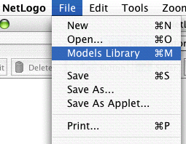
- Under File > Models Library, choose the Curricular Models/Connected Chemistry folder and open it. In the folder click on the “Connected Chemistry Ideal Gas” model and open it.

The Interface tab will fill up with buttons, switches, sliders, and monitors:
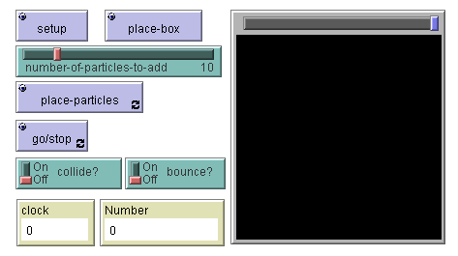

Exploration 1:
- Press the SETUP button
- Press the PLACE-BOX button. (A small gray dot will be drawn)
- Click anywhere in the black window. This is called the WORLD & VIEW. When you click in the WORLD & VIEW a yellow box will be drawn, whose corner will be drawn to where you clicked. Clicking in different locations will make different sized boxes. | 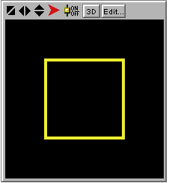
- Repeat steps 1-3, changing where you click in the WORLD & VIEW, to draw different sized boxes (which represent the sides of the “bike tire”

Activity 2 – Modeling A Tire

Exploration 2:
- If there is no yellow box in your model, repeat steps 1-3.
- Press the PLACE-PARTICLES button. The button will remain a dark black color.
- Click anywhere in the WORLD & VIEW to draw in some particles.
- Press GO/STOP and observe what happens.

As you can see, when you press the PLACE-PARTICLES button, you paint some green circles in and around the tire. These green circles represent simplified gas molecules. Although a more accurate model of air would take into account that is a mixture of substances (nitrogen, oxygen, carbon dioxide, etc), each substance having molecules with different shapes, we will use this simplified model of a pure gas, whose shape of molecules is ignored. We will refer to the simplified representation of these molecules as gas particles.

Question 1: When you pressed GO/STOP, what happened to the gas particles?

_______________________________________________________________________________________________________________________________________________________________________________________________________________________________________________

Exploration 3:
- Run the model again, in slow motion, by sliding the slow motion slider half way to the left. Be careful to not drag the slider all the way to the left (This will pause the model completely. If this happens, slide the slider back to the right).

 | 

- With the model in slow motion, repeat steps 9-11 and observe what happens.

Activity 2 – Modeling A Tire

Exploration 4:
Now run the model again (steps 1-9), but explore what the effect is of changing the switches and sliders in the model:

 |  | 

You should now be able to change the switches and slider values and summarize how these switches and sliders affect what you observe in the model.

Question 2: What do you observe the particles doing when you run the model and turn this switch to on?

_______________________________________________________________________________________________________________________________________________________________________________________________________________________________________________

Question 3: What do you observe particles doing differently now when you run the model and turn this switch to on?

_______________________________________________________________________________________________________________________________________________________________________________________________________________________________________________

Question 4: What else do you need to do, if you change this slider and want to add different numbers of particles to the world?

_______________________________________________________________________________________________________________________________________________________________________________________________________________________________________________

Activity 2 - Homework

You explored a computer model that represents air particles that are trapped in a bike tire, in order to understand some of the basic properties of gas particles. Other objects in the model were simplified to let you focus on the gas particles. For example, in future models, when it is important to focus on what is happening in a solid we may want to show the solid being made of individual molecules or particles as well. In the bike tire model, however, the solid bike tire walls were simply shown as a continuous yellow line that makes up the side of the yellow box.

Question 1: In the space to the right show what the yellow box should look like, if the “solid yellow walls” were actually modeled as being composed of separate molecules:

In upcoming activities you will continue to use variations of the bike tire model (with its continuous yellow box walls and gas particles on the inside) to study other properties of gases. For example, you will heat the bike tire in the model and change its size. All these activities rely on using and understanding how the model you are using compares to a well established scientific model for most gas behavior.

The tire model that you are using is based on theory which was developed by scientists in the 18th century to try explain and predict the behavior of gases. This theory is called Kinetic Molecular Theory (KMT). It can be used to explain and predict the behavior of different objects that use air pressure to function such as these:

KMT describes an idealized or perfect gas. KMT describes the molecules that make up a gas, as constantly moving, colliding with each other like billiard balls or pool balls and bouncing off the surface of the container holding the gas. One important features of this theory is the way that simple rules at the microscopic level (particles like atoms or molecules) can be used to explain events and relationships at the macroscopic level (things we can directly sense).

Activity 2 – Homework

Kinetic Molecular Theory describes the behavior gas particles (molecules) in a perfect or ideal gas:
An ideal gas is defined as a gas in which all the collisions between the particles are elastic and there are no forces among the particles (attraction, repulsion). One can visualize the gas as hard billiard balls which collide but do not interact otherwise. In such a gas, all the internal energy of the particles is in the form of kinetic energy. Any change in the kinetic energy is accompanied by a change in temperature.
Notice that the molecules in an ideal gas are often referred to as particles.

Notice that the collisions are referred to as elastic. This means that no energy is lost or gained when the particles collide with each other.

Notice that the definition refers the internal energy of the particles being in the form of kinetic energy. Kinetic energy is the energy that an object has due to its motion. An object that is not moving at all would have no kinetic energy. Faster moving objects have more kinetic energy than slower moving objects. And more massive objects have more kinetic energy than less massive objects.

The main assumptions of Kinetic Molecular Theory (KMT) can be summarized as the following:
- Collision between gas particles occur like collisions between billiard or pool balls.
- There are no attractive or repulsive forces between the particles.
- Any energy the particles have is because of their motion only.

Question #1a Now compare these two gases: Water vapor and Nitrogen gas. Both of these gases are found in our atmosphere. Nitrogen gas particles have far less attraction between other nitrogen gas particles, than water vapor particles have between other water vapor particles.
Which of these gases behaves more like an ideal gas? _____________________________

Question #1b What makes it more like an ideal gas?
________________________________________________________________________________________________________________________________________________________________________________________________________________________________________________
Question #2 Which of these gases behaves most like the gas particles you observed in the computer model? __________________________________________________

Question #3 Which of these gases acts more like an ideal gas? ________________.

Question #4 Why does one gas act more like an ideal gas than another? ________________________________________________________________________________________________________________________________________________________________________________________________________________________________________________

Activity 2 – Homework

Question 5: Show and describe what the air molecules are doing in this ball?

________________________________________________________________________________________________________________________________________________________________________________________________________________________________________________

Question 6: Show and describe what the air molecules are doing in this air pump when you step on the foot pedal?

_______________________________________________________________________________________________________________________________________________________________________________________________________________________________________________
In the next activity you will use the computer model to look at gas particles, paying particular attention to the rate at which the particles hit the wall. You will investigate how this measure is related to pressure.

What is pressure?

Pressure is defined as force per unit area. It is represented by the ratio of force to area:

Pressure = Force / Surface Area

This means that the pressure on a surface depend both on the force that is applied to the surface and the size of the surface. The units for one common pressure measurement, pounds per square inch, indicate this. A larger force on a surface create lead to larger pressure. A larger surface with a the same force against it leads to a smaller pressure.

Activity 2 – Homework

Let’s imagine the everyday example of a “wall” and an object hitting it that is similar to gas particles and walls of a gas container. Imagine a basketball player throws a basketball at the basket but hits only the backboard.  Question 7: What are some ways the basketball player could change the amount of pressure the ball gives to the backboard when the shot hits it? | 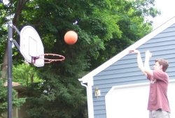
________________________________________________________________________________________________________________________________________________________________________________________________________________________________________________

Question 8: What are two ways you could increase the amount of pressure that a gas gives to the wall of the bike tire ball when it bounces off it?

________________________________________________________________________________________________________________________________________________________________________________________________________________________________________________
There are two common units used to measure air pressure.
One is pounds per square inch (or psi).
Another is the standard atmosphere (or atm).

One standard atmosphere is equal to about 14.7 pounds per square inch:
1 atm = 14.7 psi

Question 9: If the pressure gauge on an air pump read: 3 atm, what would this pressure be equivalent to if measured in psi? _______________________

Question 10: If the pressure gauge on an air pump read: 50 psi, what would this pressure be equivalent to if measured in atm? _______________________

Activity 3 – Changing Pressure

Opening the second model:
- Open NetLogo on your computer
- In the NetLogo window, open the Model Library from the File Menu
- Under File > Models Library, choose the Curricular Models/Connected Chemistry folder and open it. In the folder click on the “Connected Chemistry Changing Pressure” model and open it.

The Interface tab will fill up with buttons, switches, sliders, and monitors:

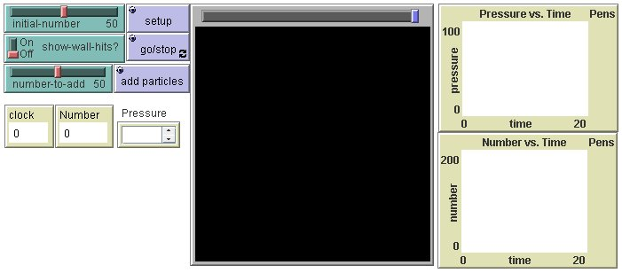

Exploration 1:
- Press SETUP.
- Repeat step #1, a few times.

Question 1 What happens to the particles each time you press the SETUP button?

________________________________________________________________________________________________________________________________________________________________________________________________________________________________________________
Exploration 2:
- Adjust the INITIAL-NUMBER slider.
- Press SETUP
- Press GO/STOP
- Repeat steps #6-9, a few times.

You should notice that the effects of INITIAL-NUMBER are only applied when SETUP is pressed. Changing INITIAL-NUMBER slider while the model is running (when GO/STOP is pressed) has no effect. Many sliders do not effect anything in the model until a button is pressed.

Activity 3 – Changing Pressure

Exploration 3:
- Turn the SHOW-WALL-HITS? switch on to help you visualize when the particles hit the wall
- Adjust the INITIAL-NUMBER-SLIDER value.
- Press SETUP and GO/STOP to run the model
- Repeat steps #11-13, adjusting the SLOW-MOTION-SLIDER to slow down the motion of the particles, until you discover what makes the pressure monitor in the model read zero: | 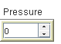

Question 2: If a particle is not hitting the wall, is it creating pressure? ___________

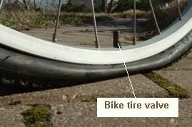 | The model of the bike tire has been modified to include a valve. It is represented by the small gap in the yellow box (as shown in the image below). This is the valve through which more air can be pumped into the tire, but air can not escape out of. | 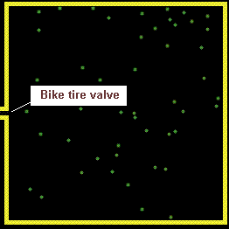

Exploration 4:
- Run the model by pressing SETUP and then GO/STOP.
- With the model running, set the NUMBER-TO-ADD slider to the number of particles you would like to add into the box by “pumping them through the valve”
- Press the ADD PARTICLES. Wait and observe what effect this eventually has on the pressure.
- Pause the model using GO/STOP.
- Use the cross-hair on the graphs to determine the time when the particles were added and then use the cross-hair on the graphs to determine the time when the pressure goes up.
- Repeat steps 15-19, adjusting the SLOW MOTION SLIDER and carefully observe the changes in the Pressure vs. Time graph.

Activity 3 – Changing Pressure

Question 3: When you use the ADD PARTICLES button to pump in more particles, what did you eventually observe in the model?
  - The pressure increased in general.
  - The pressure decreased in general.
  - The pressure changed continually with no general increase or decrease.
  - The pressure remained constant, without any changes.

Question 4: The frequency (or rate) at which the particles hit the wall describes how often the particles are hitting the walls. When there are more particles in the box:
- particles hit the wall less frequently.
- particles hit the wall more frequently.
- particles hit the wall just as frequently.

Question 5: When particles are added (using ADD PARTICLES), the pressure does not go up immediately. Explain why it takes time for the pressure to rise after the particles are added:

________________________________________________________________________________________________________________________________________________________________________________________________________________________________________________________________________________________________________________________________

Question 6: Why does the pressure continually fluctuate?

________________________________________________________________________________________________________________________________________________________________________________________________________________________________________________________________________________________________________________________________

Exploration 6:
- Run the model with at least 50 or more particles in it
- Record your best estimate of the average pressure in this box:

- Discuss with your neighbors whether your answers to the question match exactly, are close to the same, or very different from one another.

Activity 3 – Homework

In the computer exploration, you should have noticed that it takes some time for the pressure to go up after the particles are added into the box. This result from the way pressure is measured in the model: only particles hitting the wall count towards pressure.
When the particles are added into the box, they move forward from the valve across the space inside the box in the shape of a wave (this phenomena is called a pressure wave). When they are moving across the box, the pressure does not increase. Only when they hit the opposite wall, does the pressure shoot up. The time it takes the particles to go across the box is the difference in time between adding the particles and the pressure going up.

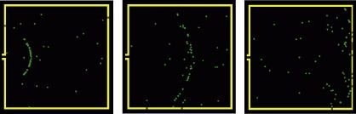

In real life, gas particles move much faster than in the model. This means that the time differences for gas particles to move across a container are very small. However, in advanced measurement devices (such as Time of Flight Spectrometers), that are used in laboratories, such time differences are actually used to identify the type of molecules in a gas. If two different types of molecules are at the same temperature they will be moving at different speed. The more massive or heavier molecules are moving slower than the other molecules  In the picture of the Time of Flight mass spectrometer on the right, at Northwestern University, the time of flight of particles is measured in femto-seconds (one quadrillionth of a second or 10⁻¹⁵ second.) | 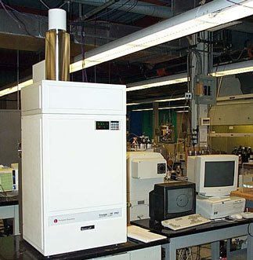

Activity 3 – Homework

Question 1: Where in the real world do you think you may have you seen, felt, or heard pressure waves (give examples)?

________________________________________________________________________________________________________________________________________________________________________________________________________________________________________________

You should have noticed that with any number of particles in the container, the pressure fluctuated around in a range of values, even when no new particles are added. When the pressure changes only a small amount, but remains within a clear range of values, it is said to be stable.

Change and stability are properties that are useful when describing processes in chemical and physical systems. You may be familiar with the term equilibrium, which denotes a stable system. The properties of a stable system are that individual parts of the system may be changing, but one or more overall properties of the system remain stable.

In the bike tire model,  - the system is: the bike tire walls and the gas particles (everything in the model).  - the properties of the individual parts that are changing are: the speed and direction of the gas particles.  - The overall property that is remaining relatively stable is: the pressure (if you don’t add any more particles).  Pressure can be described as fluctuating (its value rises and falls as time progresses), but it fluctuates within a narrow range (shown in the blue bands in the graphs on the right) when the number of particles aren’t changing.  Even after adding the more particles, by pumping up the tire, stability eventually returns to the system. | 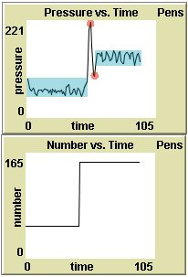

The example graphs here show what typically happens after adding particles. The pressure jumps up (after a brief delay from the time it takes them to travel across the container) and then back down. These two points are shown in as two circles highlighting a peak and a valley in the graph. But, then the pressure gradually stabilizes between a new range of values (shown as the second blue band).

Activity 3 – Homework

Question 2: If you could run the model with billions of gas particles, it would be harder to see the fluctuations in pressure (even though it is still occurring). If you run the model with only one gas particle, it is very easy to see the fluctuation in pressure. Why is it easier to see the fluctuations in pressure with only gas particle?

________________________________________________________________________________________________________________________________________________________________________________________________________________________________________________________________________________________________________________________________________________________________________________________________________________

Question 3: If wanted to model a small leak in the tire, what would you add, remove, or change in the model?

________________________________________________________________________________________________________________________________________________________________________________________________________________________________________________

Question 4: A bike tire model starts out with 50 particles, and then is punctured so that gas particles began to leak out of the tire. Sketch a graph of pressure inside the bike tire vs. time for this situation:

Activity 3 – Homework

Scientists often develop different computer models to explore and understand the same complex system. Some of the models are more precise and others are more approximate.

One reason scientists develop a model with precise rules instead of approximate rules is that detailed models allow the study of behavior of single objects in greater detail.

Question 5: Why would scientists want (or need) to sometimes build models that are more approximate?

________________________________________________________________________________________________________________________________________________________________________________________________________________________________________________
________________________________________________________________________________________________________________________________________________________________________________________________________________________________________________
When scientists use a computer model to explore and understand a complex system, they often find it helpful to try out different methods to visualize the patterns and relationships in the resulting data.

Graphs are one helpful method to visualize patterns and relationships. But sometimes, even traditional graphs can not adequately show the complex patterns that are hidden in the data.

In such cases, creative use of color, shapes, and size to represent numbers can help scientists develop a picture of their data that helps them quickly recognize patterns and relationships that would be otherwise hard to detect.

Examples of how color is used to do this include:
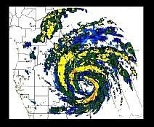 | 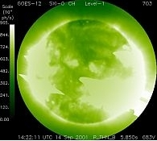 | 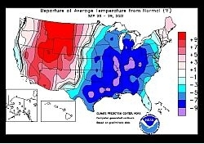
Visualizing radar reflections to create a map of rainfall intensity. | Visualizing x-ray signals to create a picture of the surface of the sun | Visualizing change from average temperatures in different locations in across the United States.
Images courtesy of National Oceanic and Atmospheric Administration

Activity 3 – Homework

Question 6: In a container of gas particles, some particles move faster than others. Show or describe one way you could use color, shape, or size to help you visualize which particles are moving the fastest:

Activity 4 – Experimenting with Particles

At this point you are going to switch from using a simplified model of gas particles in a container, to a more precise model. This more precise model will include more exact calculations of the outcome of particles colliding with one another. Also, in this model, the size of the particles will be adjustable, to help you study the outcome of these particle collisions in greater detail.

Opening the third model:
- Open NetLogo on your computer
- In the NetLogo window, open the Model Library from the File Menu
- Under File > Models Library, choose the Curricular Models/Connected Chemistry folder and open it. In the folder click on the “Connected Chemistry Circular Particles” model and open it.

In NetLogo, you can use color to represent attributes of objects in your model. Different coloring schemes may help you visualize different types of attributes. You will use color to first visualize the speed of the particles.

Exploration 1:
- Click and hold down the SHOW-SPEED-AS-COLOR select bar.
- Drag down to change setting to “Purple Shades”.

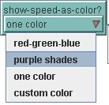
- Press SETUP and GO/STOP

You should observe that the colors of the particles are now tinted from very dark purple (slowest) to very light purple (fastest).

- Click and hold down the SHOW-SPEED-AS-COLOR select bar.
- Drag down to change setting to “Red-Green-Blue”.

You should observe that the colors of the particles are grouped into three speed categories: blue (slowest), red (fastest), and green (in between).

Activity 4 – Experimenting with Particles

Next, you will learn how to visualize a way to identify each particle. You will set each particle to show a label of its ID number that will help you identify it.

Exploration 2:
- Turn the LABELS? Switch on.
- Press SETUP and GO/STOP

Notice what the highest and lowest numbered labels for the particles are, when you have only 10 particles in the model (adjust, setup, and rerun the model if necessary).

Question 1: When you have only 10 particles in the model, what is the lowest ID number of the particles (hint: its not “1”). ____________________________

Question 2: When you have only 10 particles in the model, what is the highest ID number of the particles (hint: its not “10”) ____________________________

The Command Center is a new interface element that you will use next. You will need to use the keyboard along with the mouse, to use the Command Center.

Commands are instructions you can give to the model. All instructions need to be typed into the bottom section of the Command Center using your keyboard next to the symbols:  O>  Here is an example command that turns the number labels off (to turn a variable off, it is set to be false)  [on is the same as true off is the same as false] | 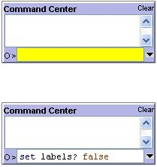

Activity 4 – Experimenting with Particles

Exploration 3:
Now use the Command Center to toggle the labels of the particles on and off:

- Press SETUP. Type the following in the white space at the bottom of the Command Center next to the O>

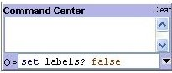

- Next make sure you press enter in the area you typed (this will make the command active).
- Press GO/STOP to test the effect of this command.
- Now type the following in the white space at the bottom of the Command Center next to the O>
set labels? true

- Press GO/STOP to test the effect of this command.

Exploration 4:
Now use the Command Center to customize the colors of particles:

- Again, click in the space at the bottom of the Command Center next to the O>.
- Use the keyboard to type the command:

set show-speed-as-color ”custom color”

- Press the enter key on the keyboard. Notice how the value of the
SHOW-SPEED-AS-COLOR? Select bar has changed.
- Use the keyboard to type this command in the Command Center:

ask particles [set color orange]

- Press enter and then GO/STOP to test the effect of this command.
- Use the keyboard to type these two commands into the Command Center:

ask particle 0 [set color white]
ask particle 1 [set color pink]

- Press enter and then GO/STOP to test the effect of this command.

Repeat any of these steps, trying other colors (red, brown, yellow, green, lime, turquoise, cyan, sky, blue, violet, magenta, gray).

Activity 4 – Experimenting with Particles

Exploration 5:
Now use the Command Center to trace the path of a particle:

- Again, click in the space at the bottom of the Command Center next to the O>.
- Use the keyboard to type the command:

ask particle 0 [pendown]

- Press the enter key on the keyboard.
- Press GO/STOP to test the effect of this command.
- Use the keyboard to type this into the Command Center:

ask particle 0 [penup]

- SETUP the model and repeat steps 26-30, while slowing down the model with the slow motion slider.

Exploration 6:
Now use the Command Center to adjust the speed of the particles:

- Press SETUP
- Use the keyboard to type into the Command Centers:

ask particles [set speed 0.01]

- Press the enter key on the keyboard.
- Use the keyboard to type this into the Command Center:

ask particle 0 [set speed 10]

- Press GO/STOP to run the model and observe the effects.
- Repeat steps 29-33, but adjust the slow motion slider to carefully study what happens to the speed of the slower particles as they collide with faster moving particles.

Activity 4 – Experimenting with Particles

Exploration 7:
Now use the Command Center to adjust the heading of the particles:

- Press SETUP
- Use the keyboard to type into the Command Center:

ask particles [set heading 90]

- Press the enter key on the keyboard.
- Use the slow motion slider to slow down the model and Press GO/STOP to run the model and observe the effects.
- Repeat steps 37-40, trying a different angle, such as:

ask particles [set heading 240]

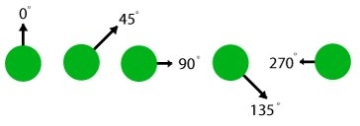

- Try to adjust the heading of one particle:

ask particle 0 [set heading 180]

Exploration 8:
Study the motion of two particle:

- Set the INITIAL-NUMBER slider to 2
- Press SETUP and then GO/STOP.
- Use the keyboard to type into the Command Center:

watch particle 0

Question 4: When a particle hits the wall only:
- The particle changes direction, but not speed
- The particle changes speed, but not direction
- The particle changes direction and speed
- Nothing changes

Activity 4 – Experimenting with Particles

Exploration 11:
Study the motion of two particles:
- With the model still running, and adjusting the slow motion slider to allow you to follow the motion of the particles, use the keyboard to type into the Command Center:

ride particle 0

You are now riding one of the particles so that everything appears to move relative to you. This is similar to the perspective you have looking out of the window of a moving car or train, it can seem like the vehicle is not moving, but the rest of the world is.

Question 5: When a particle hits another particle:

- The particles change direction, but not speed
- The particles changes speed, but not direction
- The particles changes direction and speed
- Nothing changes

Question 6: This system is not gaining energy over time and the system is not losing energy over time. Though a single particle may move slower after a collision or faster after a collision, the kinetic energy (energy of motion) of the particle is being transferred back and forth between the two particles in a collision. What evidence do you have of that energy is transferred between the particles in the model?

________________________________________________________________________________________________________________________________________________________________________________________________________________________________________________
When you have only two particles in the model, you should have noticed that when the particles collide, they can change their speed. However, you may have also noticed that if one particle’s speed went up, then the other particle’s speed went down. This is the result from a rule in the model: If there is a collision, then the particles change their speed and direction, so that the total of energy of the two particles does not increase or decrease. In science, we say that in a collision the total energy of the two particles is conserved. This means that the energy is simply transferred back and forth between particles in collision, but the energy does not increase in the model of this system.

Question 7: What evidence can you see in the graphs of the model that: in a collision the total energy of the two particles is conserved?

________________________________________________________________________________________________________________________________________________________________________________________________________________________________________________

Activity 4 – Homework

In the computer activity in class tomorrow you will collect data from a computer model, enter this data into a table, graph the data, and create and use a mathematical model (an equation) that fits the pattern in your data. You will use the data analysis methods you learn in this activity again in future activities to build other mathematical models (different equations).

When you run the computer model, like before, you will find that the pressure will be continually fluctuating. With pressure continually fluctuating in the computer model, you might find it hard to confidently choose a reasonable value for pressure to record in your data table.

To record a reasonable value in the pressure values that will be fluctuating, you will need to carefully interpret values from the graphs. To do this you will need to use your mouse. When you mouse hovers over a graph it turns into a cross-hair.

The top graph on the right shows a graph of Pressure vs. time. The cross-hair is shown in middle of this graph. Notice that the cross-hair has two numbers associated with its current position: one below it and one to the left of it. The number below it (24.9) is on the x-axis; it represents the time value at that cursor position. The number to the left of it (56) is on y-axis; it represents the pressure value at those coordinates.  Question 1: The second graph shows the mouse moved over to be on top of the last recorded pressure value on the graph. The pressure value here is 85. What is the time value at this point?  a) 123 b) 85 c) 45.4 d) 50.1  The third graph shows the cross-hair moved about half way between the highest and lowest pressure values on the graph. The range of highest and pressure values are shown as a light blue band across the graph. The cross-hair is lined up on an imaginary line (dark blue). This line does not actually show up on the computer model, but being able to picture in you mind where this “middle of blue range” or median line is located will help you determine a good estimate for the middle of the pressure range. | 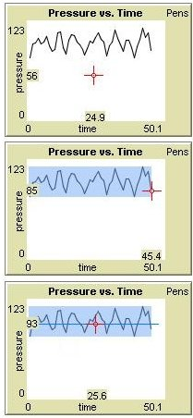

Question 2: What is the pressure value in the middle of the fluctuations in the third graph?

a) 123 b) 93 c) 25.6 d) 50.1

Activity 5 – Number and Pressure

Re-opening the second model:
- Open NetLogo on your computer
- In the NetLogo window, open the Models Library from the File Menu
- Under File > Models Library, choose the Curricular Models/Connected Chemistry folder and open it. In the folder click on the “Connected Chemistry Number and Pressure” model and open it.

Exploration 1:
- Set up and run the model with 50 particles.
- Measure the pressure value for this number of particles.
- Add 25 more particles.
- Measure the pressure value for this number of particles.
- Record these values in the table below
- Add 25 or more particles.
- Repeat steps 6-9, until your table is complete, increasing the number of particles each
Time.

Number of particles | Pressure
50
75

Question 1: What relationship do you notice between number of particles and pressure in your data table?

________________________________________________________________________________________________________________________________________________________________________________________________________________________________________________

Activity 5 – Number and Pressure

Exploration 2:
- Graph your data from your data table (put the number of particles on the x-axis, since it is your independent variable):



Question 2: Which relationship best describes your data? Does it look most like a linear relationship, inverse relationship, quadratic relationship, exponential relationship, or a different relationship? _______________________________________________________________

Activity 5 – Number and Pressure

You should have found a linear relationship between the number of particles and pressure.

Question 1b: Go back to the graph and Use a straight edge to draw a straight line of best fit for your data.

If you found this relationship, your result matches what scientists have discovered when investigating gases. If you did not find this relationship, repeat Explorations 1 and 2, collecting a new set of data.

Linear relationship can be described in terms of linear equations of the form:

y = m ▪ x + b

Where m is the slope of the line you made on you graph and b is the y-intercept on the graph.

Question 2: What is the slope of your graph? ______________________________
(math concept review: slope is calculated by the ratio of rise to run of the straight line)

Question 3: What is the y-intercept of your graph? ______________________

Question 4: Would it be reasonable if another group had a y-intercept very close to zero on their graph? _________________________

Question 5: What would a y-intercept of zero in the mathematical model represent in the computer model?

________________________________________________________________________________________________________________________________________________________________

Question 6: Slope always represents the unit rate of change in the graph (example: in a graph of distance in miles vs. time in hours, the slope represents miles per one hour). The rate of change that your slope represents is pressure per one particle. Based on this idea, do you think the rate at which a single particle hits the wall change when there are more particles in the container? ________________________________________

Explain why it will or will not change? ________________________________________________________________________________________________________________________________________________________________________________________________________________________________________________

Activity 5 – Number and Pressure

Exploration 3:
- Set up and run the model with different numbers particles.
- Study the average wall hits per particle (monitor or graph).

You should see that the average wall hits per particle fluctuates, but is close to the same value, whether you have 50 particles or 300 particles in the container. This is what your linear relationship predicts, since the slope of the data you graphed is constant, this means that though more particles yields more pressure, the ratio of pressure to number of particles remains constant (the pressure per particle does not change).

There are many important connections between the linear relationships you have studied in mathematics and the equations that are used to explain and predict the behavior of gases in science. Throughout this unit you will sometimes need to rewrite your equations in equivalent forms or symbolically manipulate the equations in order to make those connections. You will do this in the next question in order to calculate what the equations would predict would happen if you changed the settings of the computer model.

Question 7: Rewrite your linear equation in this form (replacing P for y and N for x):

P = m ▪ N + b

(P is pressure, N is number of particles, m is slope and b (the y-intercept) is approximately zero)

Your equation: ____P = _________________________________

Use this equation to substitute in all the known values and make the following predictions by solving the linear equation for P.

10 particles would give a pressure of: ___________________________

100 particles would give a pressure of: ___________________________

1000 particles would give a pressure of: ___________________________

3240 particles would give a pressure of ___________________________

How many particles are needed to give a pressure of 8200? _____________________

Exploration 3:
- Use the model to test you prediction for 10 particles.
- Use the model to test you prediction for 100 particles.

Activity 5 – Number and Pressure

Question 8: How accurate was you prediction for 10 particles:  - It was under 10 % error  - It was within 10-50% error.  - It was over 50% error | Question 9: How accurate was you prediction for 10 particles:  - It was under 10 % error  - It was within 10-50% error.  - It was over 50% error

Did you know that 10% error is considered an accurate prediction in most sciences? In some areas of science the acceptable error to be considered an prediction is much higher and in other areas, the acceptable error to be considered an accurate prediction is much lower.

Activity 5 – Homework

Question 1: Many students find that their prediction for 100 particles was more accurate than the prediction for 10 particles. Why?

________________________________________________________________________________________________________________________________________________________________________________________________________________________________________________________________________________________________________________________________________________________________________________________________________________

Question 2: Why would recording the results from multiple trials (pressing SETUP and testing over) and calculating an average, be more likely to give an answer closer to the predictions than if you just tested the computer model once?
________________________________________________________________________________________________________________________________________________________________________________________________________________________________________________________________________________________________________________________________________________________________________________________________________________
In computer models based on real-world systems we choose how to simulate and represent real world objects and phenomena (a state or event that can be sensed or observed). Only some of the real objects in a system are selected; their properties are usually simplified and we focus only on some of their interactions.

Let us review what objects were selected and some of the simplifications were made in the computer model.

- Gas particles move as fast as some insects.
- Air is made up of only one kind of gas.
- When pumping a bicycle tire, its volume does not change.
- The container is completely rigid.
- The container holds hundreds of particles.
- The geometry of the tire walls is a two-dimensional box

Activity 5 – Homework

For each of simplifications, explain what we would picture is happening in reality and why the simplification in the computer model was helpful or necessary for us. Here is an example for the first one:

I. Computer model simplification: Gas particles move as fast as some insects.
In reality, gas particles move very fast (as fast as the speed of sound) _____________________

The computer model simplification helps or is necessary because: If the model showed the particles moving this fast, we wouldn’t be able to easily see how the particles interact.________________
________________________________________________________________________________________________________________________________________________________________

II. Computer model simplification: Air is made up of only one kind of gas.
In reality, ______________________________________________________________________

The computer model simplification helps or is necessary because: ___________________________ ________________________________________________________________________________________________________________________________________________________________________________________________________________________________________________

III. Computer model simplification: When pumping a bicycle tire, its volume does not change.
In reality, ______________________________________________________________________

The computer model simplification helps or is necessary because: ___________________________ ________________________________________________________________________________________________________________________________________________________________________________________________________________________________________________

Activity 5 – Homework

IV. Computer model simplification: The container is completely rigid.
In reality, ______________________________________________________________________

The computer model simplification helps or is necessary because: ___________________________ ________________________________________________________________________________________________________________________________________________________________________________________________________________________________________________

V. Computer model simplification: The container holds hundreds of particles.
In reality, ______________________________________________________________________

The computer model simplification helps or is necessary because: ___________________________ ________________________________________________________________________________________________________________________________________________________________________________________________________________________________________________

VI. Computer model simplification: The geometry of the tire walls is a two-dimensional box.
In reality, ______________________________________________________________________

The model simplification helps or is necessary because: ___________________________________ ________________________________________________________________________________________________________________________________________________________________________________________________________________________________________________
Extending the computer model for Pressure: A central idea to understanding air pressure, is that the more air particles that hit a surface, the more pressure they will create because they generate more wall hits on that surface. But that is not all that affects the pressure of the gas.

Question 4 -If you could decrease the speed of all the air particles, how would this effect the pressure? ________________________________________________________________________________________________________________________________________________________________

Activity 6 – Temperature and Pressure

The computer model you have used in previous activities did not let you change the temperature of the bike tire or the gas inside the bike tire. In this activity, you will use a computer model that also includes the effect of warming up and cooling down the bike tire walls. This warming and cooling of the bike tire walls will eventually change the temperature of the gas.

Opening the fifth model:
- Open NetLogo on your computer
- In the NetLogo window, open the Model Library from the File Menu
- Under File > Models Library, choose the Curricular Models/Connected Chemistry folder and open it. In the folder click on the “Connected Chemistry Temperature and Pressure” model and open it.

Exploration 1:
- Press SETUP and GO/STOP to run the model.
- With the model running and the particles moving, press the WARM UP WALLS or COOL DOWN WALLS button many times. You will notice the wall change color when you do this (bright red-white is hotter and dark red-black is colder)
- Watch what starts to happen to the speed of the particles, the color of the particles (which represents their speed) and the two graphs.
- Keep letting the model run until the new temperature of the gas is stable.

Question 1: When the temperature is increased:
- The particles move faster
- The particles move slower
- The particles speed does not change

As average speed of the particles increase, so does the temperature. In fact, temperature is simply another name for the average kinetic energy of the particles. Since kinetic energy is the energy associate with the motion of the particles, a group of faster moving particles have more e for example, if you doubled the average speed of the gas particles, you would also be doubling the temperature

Question 2: If you wanted to show what happens to the gas particles in the tire, when bike tire is stored out in the garage, and the temperature outside drops, what would you do in the computer model to simulate this effect
- Press WARM UP WALLS a few times
- Press COOL DOWN WALLS a few times
- Press SETUP again

Activity 6 – Temperature and Pressure

You might have noticed that the speed of the particles did not change immediately when you heated or cooled the walls. The temperature of the gas changes gradually until it stabilizes at the temperature of the walls. Hitting the wall (which is at a different temperature), causes the particles to speed up (if the wall is warmer) or slow down (if the wall is cooler) in small increments. This process happens in the world everyday; it takes time for a hot or cold object to reach the same temperature as its surroundings. This process is called thermal equilibration; it describes a state of the system when its temperature changes until it reaches a stable value. This type of heat transfer between a solid and a gas is called conduction. Conduction represents the energy transfer that occurs when molecules of a gas, liquid, or solid collide with another particle. Though we are not visualizing individual molecules in the bike tire walls, we are modeling the energy transfer associated with conduction from the solid molecules (which would be vibrating in a solid) in the wall to the moving particles in the gas.

Look at the graph of Gas Temp. vs. Time from your computer model. You should notice the temperature has no units on the Temperature axis. The computer model does not use conventional units to label variables such as temperature, time and volume.

There are three common scales used in science to measure temperature: Farenheight, Celsius, and Kelvin.

The increments for each degree in Kelvin are the same as Celsius, but there are no negative degrees in the Kelvin scale. The lowest temperature in Kelvin is 0 K, which corresponds to the point at which molecules stop moving and therefore speed of the particles is zero (This same temperature in Celsius is approximately -273◦C).  Because it is easier to think of 0 K as corresponding to an average particle speed of zero you will use the Kelvin scale in some calculations in the remaining explorations. |  | 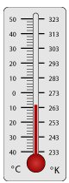
Exploration 2:
- Run the model and change the temperature of the walls until the gas particles almost stop moving.

Question 3: When the gas particles almost stop moving, what is the temperature of the gas? ________________________

Question 4: Is this temperature close to zero? ____________

Question 5: What is this temperature in ◦C? ____________

Activity 6 – Temperature and Pressure

Exploration 3:
- Set up and run the model with 200 particles.
- Wait until the temperature stabilizes, then record the temperature and the
pressure of the gas in the table below

Temperature of the gas | Pressure

- Warm or cool the walls
- Repeat steps 10-11, six different times, until you have a completed your table

Question 6: What relationship do you notice between temperature of the gas and the pressure in your data table?
________________________________________________________________________________________________________________________________________________________________________________________________________________________________________________

Exploration 2:
- Graph your data from your data table (put the number of particles on the x-axis, since it is your independent variable):

Question 7: Which relationship best describes your data? Does it look most like a linear relationship, inverse relationship, quadratic relationship, exponential relationship, or a different relationship?

_______________________________________________________________________

Activity 6 – Temperature and Pressure

You should have found a linear relationship between the number of particles and pressure.

Question 8: Go back to the graph and Use a straight edge to draw a straight line of best fit for your data.

If you found this relationship, your result matches what scientists have discovered when investigating gases. If you did not find this relationship, repeat Explorations 1 and 2, collecting a new set of data.

Linear relationship can be described in terms of linear equations of the form:

y = m₂ ▪ x + b₂

Where m₂ is the slope of the graph and b₂ is the y-intercept on the graph.

We are using a small number ₂ next to the m and the b to indicate this is a different slope and y-intercept than the one we calculated in an earlier activity. We will refer to the slope and y-intercept from that activity as m₁ and b₁

Question 9: What is the slope of your graph in this activity (m₂)? _____________
(slope is calculated by the ratio of rise to run)

Question 10: What is the y-intercept of your graph (b₂)? ______________________

Question 11: Would it be reasonable if another group had a y-intercept very close to zero on their graph? _________________________

Question 12: What would a y-intercept of zero in the mathematical model represent in the computer model?

_______________________________________________________________________________________________________________________________________________________________________________________________________________________________________________
Question 13:
Rewrite your linear equation in this form (replace P for y and T for x):

P = m₂ ▪ T + b₂

(where P is pressure, T is the temperature of the gas, b is approximately zero)

Your equation: ____P = _________________________________

Activity 6 – Temperature and Pressure

Question 13 continued:
Use this rewritten equation to substitute in all the known values and make the following predictions by solving the linear equation for P.

A temperature of 10, would give a pressure of: ___________________________

A temperature of 100, would give a pressure of: ___________________________

A temperature of 10000, would give a pressure of: ___________________________

A temperature of 3420 would give a pressure of ___________________________

What temperature is needed to give a pressure of 8200? _____________________

Exploration 3:
- Use the model to test you prediction for a temperature close to 100.

You may notice that you can’t get exactly to a temperature of 100, so try to get as close as possible.

Question 14: How accurate was you prediction for a temperature of 100:
- Reasonably accurate, considering I couldn’t get an exact temperature of 100.
- Hard to tell
- Very inaccurate

The equation relating temperature to pressure is very similar to the equation relating number of particles to pressure. Knowing they are both linear, allows you to reason about their combined effects in some interesting ways:

Question 15: If you doubled the temperature and doubled the number of particles, what would happen to the pressure?
- Nothing
- It would double
- It would quadruple (four times greater)
- It would halve
- It would be four times less

Activity 6 – Temperature and Pressure

Exploration 4:
- Use the model to test what happens when you double the temperature and double the number of particles.

You may notice that you can’t get the exactly temperature you are trying for, so try to get as close as possible.

You should notice that doubling the temperature and doubling the number of particles, quadruples the pressure (making it four times greater).

You may be wondering if there is a way to combine the equations for the number of particles and the pressure with the equation for the temperature and the pressure. There is!

Here are both of the equations you developed:

P = m₁ ▪ N + 0  (a linear equation with y-intercept of zero) |  | P = m₂ ▪ T + 0  (a linear equation with y-intercept of zero)

Here is the equation that represents the combined effects of changing the Temperature of the gas (T) and the Number of particles on the pressure of the gas:

P = m₁ ▪ m₂ ▪ N ▪ T + 0

Sometimes the two terms for slope (m₁ and m₂ ) are combined together for simplicity as a new single constant (k), where k represents m₁ ▪ m₂:

P = k ▪ N ▪ T

The k for the computer model you have been using is 0.0025.
This should be close to the value of (m₁ ▪ m₂)

Question 16: Use this new equation and the value of k provided, to predict what the pressure would be if the number of particles (N) is set to 200 and the temperature (T) is set to 200:

______________________________________________

Activity 6 – Temperature and Pressure

Exploration 5:
- Use the model to test this prediction.

You may notice that you can’t get the exactly temperature you are trying for, so try to get as close as possible.

Question 17: Use the new equation and the value of k provided, to predict what the pressure would be if the number of particles (N) is set to 50 and the temperature (T) is set to 800:
______________________________________________

Exploration 6:
- Use the model to test this prediction.

You may notice that you can’t get the exactly temperature you are trying for, so try to get as close as possible.

If the number of particles (N) is set to 200 and the temperature (T) is set to 200, you get the same pressure as if the number of particles (N) is set to 50 and the temperature (T) is set to 800:

Question 18: What is this pressure (P)? _________________________

Question 19: If the number of particles (N) is set to 100, what would the temperature need to be to give the same pressure? _____________________

Question 20: What is another unique combination of number of particles (N) and temperature (T) that will give the same pressure:? _____________________

Question 21: What does this equation predict the pressure will be when there are no particles?
_____________________

Question 22: What does this equation predict the pressure will be for when the temperatures is at absolute zero (no particle motion)? _____________________

Activity 6 – Homework

Use the new equation you developed in class that relates pressure, number of particles, and temperature in the following problems.
P = k ▪ N ▪ T

The k for the computer model you have been using in class was 0.0025.

The value you are using for k and the units of measure in the computer model, do not correspond to scales and units that are commonly used in the real world. For example, in the real world, pressure is often measured in units called psi (pounds per square inch) or atm (atmospheric units). And the number of molecules in something like a gas container are so large, that the number of moles of the gas are often reported instead of the number of molecules (1 mole of gas has 602,000,000,000,000,000,000,000 molecules or 6.02 x 10²³ molecules in it).

Let’s use some real world units and scales and try to predict some combinations of Pressure (P), number of particles (N), and temperature of the gas (T) for the same equation shown above.

For the real-world example below,
the k you will use in the equation will be 0.016 psi ▪ K⁻¹▪ moles⁻¹.

A bike tire is pumped up with air at the coldest time in the winter. At this time, the temperature is 260K or -13 ◦C and the pressure of the gas inside the bike tire is 60.0 psi. When the hottest day of summer comes around, the temperature increases another 52 ◦C higher. The bike tire will burst if the pressure exceeds 80.0 psi.

Question 1: What pressure will the bike tire reach in the summer? _____________

Question 2: Will the bike tire burst? _________

Activity 6 – Homework

Two Examples of how to find a solution for question 1:

Approach #1:

Since all increases in temperature are linearly related to pressure, find out how much the temperature increases by as a scale factor and use the same sacle factor to calculate how much the pressure increases by. The temperature increases by 52 K to 312 K. The increase from 260 K to 312 K represents an increase by a scale factor of 1.20 or an increase to 120% its starting value. Temperature is linearly related to pressure, so the pressure should also increase by a scale factor of 1.20 or and increase to 120% its starting value (which was 60 psi). This gives a pressure in the summer time of 1.20 ▪ 60.0 psi = 72 psi.

Approach #2.

Use the equation to solve for the number of molecules in the tire to start with.
P = k ▪ N ▪ T
60.0 psi = ( 0.016 psi ▪ K⁻¹▪ moles⁻¹ ) ▪ N ▪ (260 K)

which when it symbolically manipulated to solve for N, gives
N = 60.0 psi / [( 0.016 psi ▪ K⁻¹▪ moles⁻¹ ) ▪ (260 K) ]
N = 14.4 moles

Use this number of moles to figure out the pressure in the summer (since no air escapes or is added to the tire, the number of moles does not change in the tire).
P = k ▪ N ▪ T
P = ( 0.016 psi ▪ K⁻¹▪ moles⁻¹ ) ▪ 14.4 moles ▪ (312 K)

P = 60 psi / [( 0.016 psi ▪ K⁻¹▪ moles⁻¹ ) ▪ (260 K) ]
P = 71.9 psi

Activity 6 – Homework

The model to the right is a container with gas particles in it. These particles are at a low temperature so they are moving slowly. To show that they are moving slowly, add small arrows to each particle. The direction of the particle shows where it is headed and the size of the arrow will show how fast it is moving.  Question 3: add arrows to the gas particles in Picture 1 to show which direction they are moving in different directions and to show how fast they are moving. | 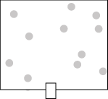  Picture 1

In this next picture, two particles of gas have been into the container through a valve (at the bottom). These two particles are at a very high temperature. To show they are moving fast, we have drawn a long arrow on each of their paths. The rest of the gas molecules  Question 4: add arrows to the gas particles to represent their velocity (speed and direction). | 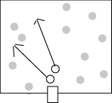  Picture 2

Question 5: Draw Picture 3, to show what the model of the particles and container would look like after the two particles are given time to collide with the other particles over and over ( show the particle velocity arrows)  Question 6: What will have happened to the temperatures of the two gas particles that were added in?  Question 7: What will have happened to the temperature of the gas particles that were originally in the container? | Picture 3

Activity 6 – Homework

Your answer to questions 1-5 help demonstrate two ways in which heat is transferred or moves from one location to another. One of these ways is called convection; it happens when faster moving particles move into the space where slower moving particles are. The second way is called conduction; in this case this is when particles collide and exchange energy between each other. Earlier, you were introduced to conduction between the gas and the solid wall.

Question 8: Imagine you open the freezer door at the gas station and leave it open. The temperature of the air in the store drops slightly. Is this due to convection, conduction or both?
_______________________________________________________________________
Question 9: As you keep the freezer door at the gas station open, the temperature of the air inside the freezer goes up. Is this due to convection, conduction or both?
_______________________________________________________________________
Question 10: Describe what is happening to the gas particles in the air that would explain why the temperature is changing in the air inside the freezer and outside the freezer:
________________________________________________________________________________________________________________________________________________________________________________________________________________________________________________
________________________________________________________________________________
Question 11: The variable that has remained unchanged (or constant) in all the activities so far has been:

a) The number of particles | b) The temperature of the gas
The volume of the container | - The pressure of the gas

Question 12: A closed glass tube is filled with air. One end of the tube is held over a flame. Will the air on the other side become warmer? Choose the best answer:
- No. Only the tube is heated. The air particles stay at the same temperature, because they do not touch the flame.
- No. The flame heats up only the part of the tube that is above it. When particles hit the hot part of the tube, they will speed up. However, this will heat up only the gas that is above the flame. The other side will not warm up.
- Yes. When the air particles hit the heated tube, they speed up. Since they move inside the tube they can reach the other side too. Because they collide with each other, exchanging energy with other particles, the other particles eventually become faster as well, so that all the gas becomes hotter.
- Yes. When the air particles hit the heated tube, they speed up. Since the particles are in constant motion, the faster particles will eventually reach the other side of the tube as well, and the temperature will go up on that end and then when those particles bounce back to the flame side, the temperature will go back down.

Activity 6 – Homework

In the next activity you do in class you will explore the relationship between the pressure of a gas and the volume it occupies. In class, you will again use the syringe you used in the first activity. You collect real-world data of the quantity of gas is trapped in a syringe. The pressure of the gas, will then be increased by weights (books) on top of the plunger of the syringe. A diagram of the lab apparatus you will be using is shown below:

 | 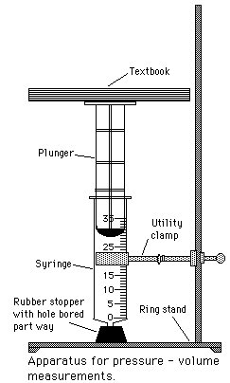
  Question 13: Draw a model of the syringe and the air particles inside the syringe, when no books are placed on the top of the syringe and the end is plugged with the stopper.

Question 14: Now consider the air particles that are outside of the syringe. Do these air particles also push on the outside walls of the syringe? _______.

Question 15: Circle the diagrams that represent the most accurate model of the air inside and outside the syringe when there are no books on it?

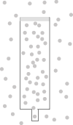 |  | 

Activity 6 – Homework

Question 16: Use the representation you choose in question 3 to show how the air particles would change as you added more books as weight on top of the top plunger?

model with 2 book weights added to the top of the plunger | model with 4 book weights added to the top of the plunger | model with 8 book weights added to the top of the plunger

Extending the model for Pressure: A central idea to understanding air pressure is that more gas particles create more pressure, because they generate more wall hits. Another central idea to understanding air pressure is that faster gas particles create more pressure, because they hit the walls more frequently. Thinking about how frequently the walls are hit, accounts for the contribution of the number of particles and their speed (or temperature). Thinking about how frequently the walls are hit can also help you predict what will happen if you change the volume of the air container.

Question 17: As more books are added to the top of the plunger, the volume of syringe decreases. As the volume decreases, the space the particles have to move around inside the syringe decreases. The particles of air become more dense inside the syringe and hit the wall more often. As the air particles hit the syringe wall more often, what will this do to the pressure inside the syringe?
________________________________________________________________________________________________________________________________________________________________
________________________________________________________________________________
________________________________________________________________________________________________________________________________________________________________
________________________________________________________________________________

Activity 7 – Volume and Pressure

What is the relationship between the pressure of a gas and the volume it occupies? In this experiment, a given quantity of gas is trapped in a syringe. The pressure of the gas, will then be increased by weights (books) on top of the plunger of the syringe.

Materials needed:

- Ring stand
- Utility clamp
- 8-textbooks (identical)
- 35 ml plastic syringe
- Tape measure and ruler
- Large rubber stopper*

Pre-lab preparation:

*Using the proper size drill bit or cork-boring tool, bore a hole approximately the length of the nipple on the syringe, in the small end of the large stopper.

Liters (L ) and milliliters (mL ) are common measurement units for volume.
There are 1000 mL in 1 L.

Inches can be converted to cm, by the following rule: 1 inch = 2.54 cm.

Question 1: How many liters of air are in a 35 mL syringe?_____________________

Question 2: How many of these syringes, full of air, would it take to fill a 1 L balloon?

______________________________________________________________________

Activity 7 – Volume and Pressure

Exploration 1:
- Calculate the surface are of the bottom of the plunger in square inches (in²). You will need to take a measurement or two with a ruler or a tape measure on the cylinder to complete this calculation: ______________________ in²

- Place the tip of the syringe into the rubber stopper. Clamp the syringe-stopper arrangement in an upright position, as shown in the drawing. Be sure not to tighten the clamp to tightly or the syringe will bind and your data will be affected.

- Carefully center a textbook on top of the plunger. One person will steady the books while the other reads the volumes. Read as precisely as possible the volume of gas trapped in the syringe when a load of one book is on the plunger. Record the volume of gas in milliliters, for one book (trial 1), in Table 1).

- Now add another textbook and carefully determine the volume. Continue in this manner until a pressure of 6 or 7 books is obtained. Record your data in Table 1 for trial 1. It is important to keep the books centered over the plunger so the apparatus does not tip. DO NOT WORRY IF THE SYRINGE DOES NOT RETURN TO THE ORIGINAL VOLUME WHEN THE BOOKS ARE REMOVED. THIS IS NOT DUE TO AIR LOSS, BUT TO FRICTION BETWEEN THE PLUNGER AND THE SYRINGE. DO NOT ATTEMPT TO CORRECT FOR IT.

- Repeat steps 1 through 3 two more times, and record your data in DATA TABLE 1, for trials 2 and 3. BE SURE TO REMOVE THE SYRINGE FROM THE CORK BETWEEN EACH TRIAL AND REFILL THE SYRINGE WITH AIR. THEN POSITION THE SYRINGE AS BEFORE

- Calculate the average volumes in Table 1.

Table 1 |  | Volume measures in milliliters (ml)
Load of books on cylinder | Pressure on cylinder (books per in²) | Trial 1 | Trial 2 | Trial3 | Average
0
1
2
3
4
5
6
7

Activity 7– Volume and Pressure

Question 3: What relationship do you notice between pressure and volume in your data table?
________________________________________________________________________________________________________________________________________________________________________________________________________________________________________________

Exploration 2:
- Graph your data from your data table (put the external pressure on the x-axis and the volume on the y-axis):

Question 4: Which relationship best describes your data? Does it look most like a linear relationship, inverse relationship, quadratic relationship, exponential relationship, or a different relationship?

Activity 7– Volume and Pressure

You should have found an inverse relationship between the number of particles and pressure.

Question 5: Go back to the graph and draw a curved line of best fit for your data on your graph.

Opening the sixth model:
- Open NetLogo on your computer
- In the NetLogo window, open the Model Library from the File Menu
- Under File > Models Library, choose the Curricular Models/Connected Chemistry folder and open it. In the folder click on the “Connected Chemistry Volume and Pressure” model and open it.

The computer model you have used in previous activities did not let you change the volume of the bike tire. While many gas containers like the bike tire, have very rigid walls, even the containers made of the strongest materials (like rock, concrete, metal, etc…) bend and deform (change shape) a very little bit when pushed against.

Other gas containers, like balloons, inner tubes, syringes, and pistons, have clearly observable volume changes associated with them when the amount of gas or pressure of the gas inside changes. |  |  | 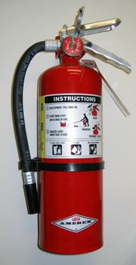

In the next activity, you will use a computer model that also allows you to adjust the volume or size of the bike tire or gas container (like an inflatable inner tube). This computer model will have an important simplification related to volume.

In the picture at the top you can see that the container is now split into two sections. In the picture below, you can see that we have put all the gas particles into the section on the left. Imagine you removed the wall that divides the two sections in half.

Question 6: What do you think will happen to the particles when this happens? _______________________________________________________________________

Question 7: How do you think increasing the volume in this manner would affect the pressure of the gas? ________________________________________________________________________________________________________________________________________________________________________________________________________________________________________________

Activity 7– Volume and Pressure

Exploration 3:
- Press SETUP and GO/STOP to run the model.
- With the model running and the particles moving, press the MOVE WALL button. You will notice the model stops for a moment.
- Click anywhere in the black to the right of where the wall currently is. The wall will move.
- Press GO/STOP to resume the running of the model.

Notice that the pressure changes when you move the wall, but the pressure takes a while to stabilize. This is similar to what you saw when you added particles to the bike tire model. This is one way you can adjust the volume of the gas container.

- Adjust the INITIAL-WALL-POSITION slider
- Press SETUP and GO/STOP to run the model.

This is the other way you can adjust the volume of the gas container.

Exploration 4:
- Set up and run the model with 200 particles.
- Change the volume of the container.
- Record the pressure of the gas once it is stabilized in the table below.
- Repeat steps 16-17 data for seven different volumes of the container.

Volume of the container | Pressure

Question 8: Does your data match your prediction for question 7? _____________________

Activity 7– Homework

Question 1:
Graph your data from your data table from the computer (put the volume of the container on the x-axis, since it is your independent variable):

Question 2: Does the graph drawn here use the same intervals, scales, and units as the graph you made of the pressure from the books vs. the volume of the syringe? ______________________

Question 3: Taking into account that the scales and intervals of this graph are different than the graph you made of the pressure from the books vs. the volume of the syringe, does the graph still have the same general trend (or the same overall shape) as the graph you made of the pressure from the books vs. the volume of the syringe? ______________________

Activity 7– Homework

In both the data from the books on the syringe and the computer model, you should have found a inverse relationship between the temperature of the gas and the pressure.

The shape of the graph of such relationships is as follows:

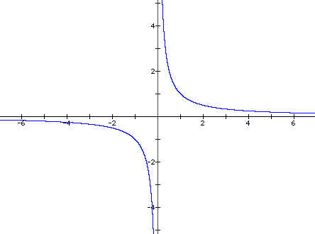

If you look at the first quadrant (upper right quarter) of this graph, it should have the general shape of the graphs you made. If you found this relationship, your result matches what scientists have discovered when investigating gases.

Inverse relationships can be described in terms of linear equations of the form:

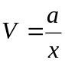

The term “a”, represents a constant coefficient. Or in terms of pressure (P) and volume (V) and k₃ (where k₃ represents the same coefficient as “a”):

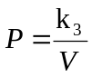

Activity 7– Homework

With symbolic manipulation of the variables to solve for k₃ (by multiplying both sides of the equation by V), you could rearrange the equation to get this:

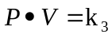

Question 4: Use this form of the equation to calculate what the value for k₃ is from your data table of the computer model: ____________ (value for k₃ in the computer model)

Your value for k₃ should be close to 360,000. This is the value that you should always get in this computer model when you calculate the product of the Pressure (P) and the Volume (V). It is a constant result you should get no matter what combinations of Pressure and Volume you measure.

Question 5: Use this equation to calculate a real-world k₃ from your data table of the real-world book pressure lab: ____________(value for k₃ in a real lab)

Your value for this k₃ will be different. But for all measurements in the real-world you should always get this constant value when you calculate take the product of the Pressure (P) and the Volume (V)

Use the value for k₃ in the real lab, to make some predictions:

Question 6: What was the air volume in the syringe when there were seven books on it? (Check your data table) _________________

Question 7: What do you predict the air volume of the syringe would be if there were fourteen books on it? (Use the equation) _________________

Question 8: What do you predict the air volume of the syringe would be if there were seventy books on it? (Use the equation) _________________

Question 9: In the first activity of this unit you thought about why it is difficult to push the plunger all the way to the bottom of the syringe. It is actually impossible to do this. How do the equation and these calculations help explain why you can NOT push the syringe all the way to the bottom?

________________________________________________________________________________________________________________________________________________________________________________________________________________________________________________

Activity 7– Homework

Use the value for k₃ in the computer model, to make some predictions:

Question 10: If you set the computer model to have the same number of particles as the data you collected, and set the volume to be 3000, what would the pressure be (To calculate this, use the equation and the value for k₃ in the computer model). _________________

Question 11: If you increased the volume to be 15000, how many times bigger is this then the current volume _________________________________________?

Question 12: At a volume of 15000, the pressure would drop to: _______________

Question 13: If you start with a container of gas and measure its volume and pressure (state 1), and then increase the volume of a container to be two times larger (state 2), explain how you know that the pressure should drop to be one-half what you started with :

________________________________________________________________________________________________________________________________________________________________________________________________________________________________________________
________________________________________________________________________________________________________________________________________________________________

Question 14: If your gas container is at state 2 (in question 13) and then you pump gas particles into the container, until you have doubled the number of gas particles you started with (now you are at state 3), you will be back to same pressure as you started. You now have twice the volume and twice the number of particles. This means that you now have the same density of gas particles as when you started (state 1) and these hit the walls just as often as in state 1. Draw three pictures which show the air particles inside the gas container in each of the scenarios:

State 1 | State 2 (double the volume) | State 3 (doubled the volume and doubled the number of particles)

Activity 7– Homework

The type of thinking you are doing in the previous question, suggests that there might be a way to combine the effects of the number of particles and the volume of the container, into a single equation to predict pressure. There is!

Here are both of the relevant equations you developed:

 = m₁ ▪ N + 0  (a linear equation with y-intercept of zero) |  | (a inverse equation)

Here is the equation that represents the combined effects of changing the Volume of the gas container (V) and the Number of particles (N) on the pressure of the gas:

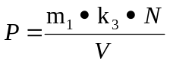

Sometimes the two coefficients (m₁ and k₃ ) are combined together to make a new single constant (k):

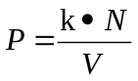

The k for the computer model you have been using
(when the temperature remains constant) is 3600.
This should be close to the value of (m₁ ▪ k₃)

Question 15: Use this new equation and the value of k provided, to predict what the pressure of the gas would be if the number of particles is set to 200 and the volume of the container is set to 1000:
______________________________________________

Here we have shown how to combine the effects of number of particles and volume of the container. Earlier we had shown how to combine the effects of number of particles and the temperature of the gas. Is there a way to reason about how to combine the effects of these variables? Yes there is! You will discover what the equation is in the next activity. On the next page, let’s try to reason out how these variables might be related.

Activity 7– Homework

Question 16: If you wanted to make the pressure of a gas container as high as possible, how would you adjust these three variables:

the number of particles (N)
- make it as high as possible
- make it as low as possible

the temperature of the gas (T)
- make it as high as possible
- make it as low as possible

and volume of the container (V)
- make it as high as possible
- make it as low as possible

The next question is very challenging. To help you develop a reasonable mathematical model of the equation for pressure, let us review the relationships we have discovered so far:

- the number of particles (N) – is linearly related to pressure (P)
- the temperature of the gas (T) – is linearly related to pressure (P)
- the volume of the container (V) – is inversely related to pressure (P)

Here were the three basic equations you developed:

P = m₁ ▪ N + 0 | P = m₂ ▪ T + 0 | 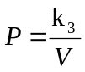

Question 17: Use your reasoning to create an equation, which you think represents the combined effects of these three variables (N, T, and V). [You equation should also have a constant (k) in it which represents the combined contribution of the other constants and slopes: m₁ and m₂ and k₃:

P = ___________________________________________________________

The relationship you are trying to make a reasonable mathematical model of is called the ideal gas law. It is a relationship that summarizes how all the variables you have studied are interrelated. It is a compact and very useful equation that allows scientist to make predictions about the behaviors of many gases in a variety of situations. You will learn more about the ideal gas law in the next activity.

Activity 8 – Ideal Gas Law

Let us first test your prediction from homework question 16, about how you could maximize the pressure in the computer model. You have three variables that you can change.

Question 1: Summarize the three variables, and how you will change them to make the maximum pressure possible in the computer model

- _________________________________________________________________
- _________________________________________________________________
- _________________________________________________________________

Opening the seventh model:
- Open NetLogo on your computer
- In the NetLogo window, open the Model Library from the File Menu
- Under File > Models Library, choose the Curricular Models/Connected Chemistry folder and open it. In the folder click on the “Connected Chemistry Ideal Gas” model and open it.

Exploration 1:
- Adjust any of the settings (the number of particles, the temperature, and the wall position) you wish in the model to try to maximize the pressure.
- Press SETUP and GO/STOP to run the model.

Watch the pressure graph to see if you are at the maximum pressure so far. The maximum pressure should be above 2000 and below 3000.

- When you think you have reached the maximum pressure possible in the model, record its value in the table below, along with the other settings in the model:

Maximum Pressure Challenge Values
Pressure of the gas (P)
Number of particles (N)
Temperature of the gas (T)
Volume of the container (V)

- Compare your maximum pressure value to a neighbor’s result. You value should be within a 10% range above and below their maximum recorded pressure value.

Activity 8 – Ideal Gas Law

Use this checklist to identify any variables you used to try to maximize the pressure in the model:

Did you add the maximum number of particles (400) to the computer model? Particle wall hits cause pressure, so more particles will yield more pressure.

Did you increase the temperature of the walls (using the WARM WALLS button) as high as the computer model will go (maximum allowable temperature in the model is 700)? Higher temperature gas particles are faster moving particles. Faster moving particles hit the walls with more force and hit it more frequently, yielding more pressure.

Did you use the smallest volume of container possible (using the INITIAL-WALL-POSITION slider)? Smaller volumes, give less space for the particles to move in between wall hits, so that gas particles hit the wall more often, since they also have less space to travel between walls. Therefore, these more frequent wall hits in a smaller volume will result in more pressure.

Now lets check the equation you developed for question 17, in which you used your
reasoning to create an equation to represent the combined effects of these three variables: N, T, and V. [You equation should also have a constant (k) in it which represents the combined contribution of the other constants and slopes: m₁ and m₂ and k₃:
Question 2: Rewrite you predicted equation for the ideal gas law here:

P =
___________________________________________________________

The actual equation for the ideal gas law is sometimes written in this form: |  | 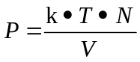

Question 3: Describe what parts of the ideal gas law equation you predicted correctly and which parts are different from your prediction:

________________________________________________________________________________________________________________________________________________________________________________________________________________________________________________
________________________________________________________________________________________________________________________________________________________________

Activity 8 – Ideal Gas Law

As stated on the last page, the equation for the ideal gas law is sometimes written in this form:

Question 4: Describe how this equation takes into account the operations that are shown in the statements below:

- the number of particles (N) – is linearly related to pressure (P)

_______________________________________________________________________

- the temperature of the gas (T) – is linearly related to pressure (P)

_______________________________________________________________________

- the volume of the container (V) – is inversely related to pressure (P)

_______________________________________________________________________
Now let’s us this equation to make some predictions. First we will use the data we collected from the maximum pressure challenge in Exploration 1, to calculate k in the equation. Here is what you know and what you have to solve for:

 | Maximum Pressure Challenge Values
Pressure of the gas (P) | Known (see Exploration 1 table)
Number of particles (N) | Known (see Exploration 1 table)
Temperature of the gas (T) | Known (see Exploration 1 table)
Volume of the container (V) | Known (see Exploration 1 table)
constant (k) | Unknown – use the equation

Question 5: In this box, show how you can use the equation to find k, using your known values from the table in Exploration 1:

Activity 8 – Ideal Gas Law

Your value of k should be close to 10. If it is not (if it is below 9 or above 11), double check your use of the equation and ask a neighboring group member for assistance.

 | Pressure  Prediction #1 | Pressure  Prediction #2 | Pressure  Prediction #3
Predicted Pressure (P)
Number of particles (N)
Temperature of the gas (T)
Volume of the container (V)
constant (k) | ~10 | ~10 | ~10

Exploration 1:
- Pick a new set of values for the number of particles (N), the temperature (T), and the volume (V) that are reachable within the model (remember you can’t exceed the maximum values you found in the previous exploration).
- Fill out the Pressure Prediction #1 column with these values (the white section of the table).
- Use the ideal gas law equation, to predict what the pressure would be and enter your prediction into the Predicted Pressure (P) for the white section of the table.
- Setup and run your model and adjust the settings to get as close as possible to the values you set for number of particles (N), the temperature (T), and the volume (V).

Some temperatures and volumes, will not be exactly reachable, since the model only allows you to increase and decrease these values in fixed increments. Get as close as you can to these values.

- Compare your predicted pressure to the actual pressure value in the model. Record the actual pressure value the model gave here: _______________

Question 6: Was the equation helpful in predicting a pressure that was relatively close to the result from the computer model: _______________

Question 7: What in the computer model might have contributed to small errors in the prediction: | ________________________________________________________________________________________________________________________________________________

Activity 8 – Ideal Gas Law

If you wish, you may rerun the computer model again to try to eliminate some of the errors in measurement of the pressure. One helpful technique to eliminate some errors in prediction is to calculate an average temperature, based on multiple computer model runs with the same settings.

Now let’s use the computer model and ideal gas equation to make some more predictions:

Exploration 2:
- Go back to the table of pressure predictions and complete the following for the gray sections of the table:
- Copy the value for Predicted Pressure (P) from the column for Pressure Prediction #1, into the column for Pressure Prediction #2 and copy it into the column for Pressure Prediction #3. Each column should now have the same value for the Predicted Pressure of the gas (P) written in it.
- In the column for Pressure Prediction #2, write down a new combination of number of particles (N), the temperature (T), and the volume (V) that is different than what you had in Pressure Prediction #1, but that you calculate will yield the same Predicted Pressure (use the ideal gas law equation to do this calculation).
- In the column for Pressure Prediction #3, write down another combination of number of particles (N), the temperature (T), and the volume (V) that is different than what you had in Pressure Prediction #1 and #2, but that you calculate will yield the same Predicted Pressure (use the ideal gas law equation to do this calculation).
- Setup and run your model and test both of your predictions.

Some temperatures and volumes, will not be exactly reachable, since the model only allows you to increase and decrease these values in fixed increments. Get as close as you can with the model

- Compare your predicted pressure to the actual pressure value in the model.

Activity 8 – Homework

Question 1: Study the sample computer model data in this table. Why do both model setting give the same pressure?
   | Settings A | Settings B
  Number of particles (N) | 750 | 50
  Temperature of the gas (T) | 520 | 65
  Volume of the container (V) | 6000 | 50
  constant (k) | ~10 | ~10
________________________________________________________________________________________________________________________________________________________________________________________________________________________________________________
As stated on in the last activity, the actual equation for the ideal gas law is sometimes written in this form:

Sometimes, the variables in an equation for the ideal gas law are symbolically rearranged (using algebraic manipulation) to an equivalent form, such as: |  | 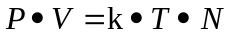

In this form of the equation, the division operation for volume (V) is inverted to become multiplication, when the variable is moved to the left hand side of the equation. Sometimes this form is preferred for making predictions and calculations on paper, since it starts out in a form that uses only the multiplication operation.

You can use an equivalent form of the equation for the ideal gas law to show that a set of values for P, V, k, N, and T are still equivalent. For example if k is 10, and V is 600, and N is 50 and T is 120, then both equations should show that P must be 1500:

First form of the  ideal gas law:  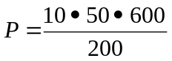  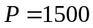 |  | Equivalent form for the  ideal gas law:  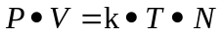  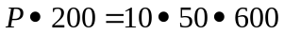  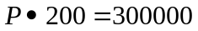  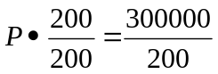

Activity 8 – Homework

Question 2: Use two forms of the ideal gas law equation to show that by using your values from your pressure prediction #2 (from Activity 8) with algebraic substitution, you get the same values in both equations:

First form of the  ideal gas law: |  | Equivalent form for the  ideal gas law:

Question 3: Use two forms of the ideal gas law equation to show that by using your values from your pressure prediction #3 (from Activity 8) with algebraic substitution, you get the same values in both equations:

First form of the  ideal gas law: |  | Equivalent form for the  ideal gas law:

Activity 8 – Homework

Question 4: Use the ideal gas law equation to create an equivalent form of the equation that would be used to solve for only V (volume), when the values of all the variables (P, V, k, N) are known.  (Hint: Move the variables P from the left side of the equation to the right side of the equation, by undoing the multiplication operation). | Equivalent form for the  ideal gas law:  Equivalent form for the  ideal gas law:  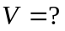

Question 5: Use the ideal gas law equation to create an equivalent form of the equation that would be used to solve for only T (temperature), when the values of all the variables (P, V, k, N) are known.  (Hint: Move the variables k and N from the right side of the equation to the left side of the equation, by undoing two multiplication operations). | Equivalent form for the  ideal gas law:  Equivalent form for the  ideal gas law:  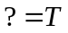

Activity 8 – Homework

Now you have seen how the ideal gas law can symbolically rearranged into many equivalent forms, such as:

The standard form of the ideal gas law, shown in textbooks is similar to this first form, with some small differences: |  | 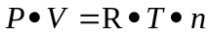

In the standard form of the ideal gas law (N) has been replaced with (n). The small letter n stands for a measure of moles of the gas. One mole of gas contains 6.02▪10 ²³ particles of gas. This large number of gas particles is closely related to the amount of gas found in many common objects that contain gases and use the behavior of gases to operate (e.g. bike tires, air pumps, balloons, etc..) In the real world, its easier to say that an object contains a specific number moles of gas (12.3 moles, 0.4 moles, etc…), instead of reporting the number of gas particles it contains. It would be cumbersome to use such large numbers in calculations and equations, so it is more convenient to replace the number of particles with a measure of moles (e.g. the bike tire contains 0.1 moles of air, the balloon was filled with 1.4 moles of air, etc..)

Also, (k) is replaced with (R). k and R are both symbols for constants. k was a constant that was calculated from the computer model. R is constant that is calculated from real-world measurements of ideal gases. It is often called the universal or ideal gas constant. When you measure pressure, volume, and temperature in common real-world units (such as atm, moles (mol), liters (L), and ºK), then the value for R is:

R = 8.2057 x 10⁻² L ▪ atm ▪ moles⁻¹▪ K ⁻¹

Now lets practice using the ideal gas law equation to make predictions, using real world scales and units.

Example Problem 1: Suppose you have 1.00 mol of a gas at 300 K, occupying a container which is 500 mL in size. What is the pressure of this gas in atm.?

P ▪ (0.5 liters) = (8.2057 x 10⁻² L▪atm▪moles⁻¹▪ K⁻¹) ▪ (1.00 moles) ▪ (300 K)

P ▪ (0.5 L) = (24.6171 L▪atm)

P ▪ (0.5 L) ÷ (0.5 L) = (24.6171 L▪atm) ÷ (0.5 L)

P = 49.2342 atm

Activity 8 – Homework

Question 6: Suppose you have 5.50 mol of a gas at 330 K, occupying a container which is 2.5 L in size. What is the pressure of this gas? (Show your work or explain your reasoning). |  | Question 7: Suppose you have a 20L tank at 260 K with a pressure of 0.8 atm , how many moles of gas are in the container? (Show your work or explain your reasoning).

Question 8: Suppose you have a 100 mL syringe of gas with a pressure of 2.45 atm, containing 0.06 moles of gas. What is the temperature of the gas in the container? (Show your work or explain your reasoning).

Question 9: A basketball is found to have a pressure of 4 atm, at 25 °C in the summer. It bounces well at this pressure. It is stored in the garage and brought back out in the winter. In the winter is still the same size, but doesn’t bounce as well. The temperature outside is now -5 °C. What is the new pressure in the basketball? (Show your work or explain your reasoning). | Question 10: Explain or show a model of what has happened to air particles that would have caused this:

Activity 9 – Modeling Real World Systems

In the next computer model you will be given a great deal of freedom to “sketch up” a model idea and test it. To start you off, spend some time messing about with what you can do with the Particle Sandbox.

Opening the fifth model:
- Open NetLogo on your computer
- In the NetLogo window, open the Model Library from the File Menu
- Under File > Models Library, choose the Curricular Models/Connected Chemistry folder and open it. In the folder click on the “Connected Chemistry Gas Particle Sandbox” model and open it.

Exploration 1:
- Press SETUP and GO/STOP to run the model.
- With the model running and the particles moving, set the MOUSE-SETTING chooser to “draw basic wall”.
- The press the MOUSE-ACTION button so that it turns black.
- Lastly, use your mouse and mouse button to draw walls in the WORLD & VIEW: move your mouse cursor to the black WORLD & VIEW and press and hold down the mouse button and move your mouse cursor around.

You should see gray squares being drawn in the WOLRD & VIEW. These are insulated walls that the particles can bounce off of.

- Now try to change the DRAW-THIS chooser setting to another value (such as “big eraser” or “paint particles green”) and repeat step 24.

Activity 9 – Modeling Real World Systems

Exploration 2:
- Now try to change the DRAW-THIS chooser setting to “slow particles”
- Use your mouse and mouse button to select particles in the WORLD & VIEW that you want to slow down: hold the mouse button down and you will see a square and circle appear under the mouse. All particles that pass under this area will be slowed down.
- Watch what happens to the TEMPERATURE OF GAS plot.

- Now try to change the DRAW-THIS chooser setting to “draw red removable wall”
- Use your mouse and mouse button to draw walls in the WORLD & VIEW: move your mouse cursor to the black WORLD & VIEW and press and hold down the mouse button and move your mouse cursor around.
- With the model running (press GO/STOP), repeatedly press REMOVE/REPLACE RED WALL

You should see the red wall appearing and disappearing as you toggle the mouse button. This is like opening and closing a valve, removing and replacing a lid, or opening and closing a door in the system.

When a perfume container is opened, the molecules of the perfume diffuse through the air into the room they are opened in. It takes a while for the perfume molecules to completely diffuse into the whole room. This is in part, because the perfume molecules collide with the air molecules in the room as they escape from the perfume container after the lid is opened.

Exploration 3:
- Challenge: Try and create a model of diffusion of a perfume from a closed perfume container that is opened. Include a way to visualize or show the difference between the surrounding air molecules on the outside of the container and the perfume molecules inside the perfume container. Also include a lid on the container that you can open and close. Your goal is to study how the perfume inside the container moves across the rest of the system (e.g. a room) once the container is opened.

Activity 9 – Modeling Real World Systems

Question 1: Describe any interesting observations, effects, or outcomes you noticed when you ran your perfume diffusion model:
________________________________________________________________________________________________________________________________________________________________________________________________________________________________________________
________________________________________________________________________________________________________________________________________________________________
________________________________________________________________________________________________________________________________________________________________

Exploration 4:
- Challenge: Try and create a model of a different system of your choice. Include whatever you wish. Think about any interesting situation (real or imaginary) that you would like to model. Then try and build it.

Question 2: Describe what you built or included in the most interesting model you made:
________________________________________________________________________________________________________________________________________________________________________________________________________________________________________________
________________________________________________________________________________________________________________________________________________________________
________________________________________________________________________________________________________________________________________________________________

Question 3: Describe any interesting observations, effects, or outcomes you noticed when you ran your new model:
________________________________________________________________________________________________________________________________________________________________________________________________________________________________________________
________________________________________________________________________________________________________________________________________________________________
________________________________________________________________________________________________________________________________________________________________

Activity 9 – Homework

Question 1: Show a model of what happens to the air molecules in a capped syringe when you add books on top of it:

Before You Add Books | After You Add Books

Question 2: What, if any pressure change does your model predict will happen when you add the books:

________________________________________________________________________________________________________________________________________________________________
Question 3: Show a model of what happens to the gas molecules and the plunger in a capped syringe with books on top of it, if you heat it and then cool it. Label the cylinder and the end of the plunger:

With books | With books and heated | With books and cooled

Activity 9 – Homework

Question 4: What, if any pressure change does your heated and cooled syringe model predict:

________________________________________________________________________________________________________________________________________________________________
________________________________________________________________________________

Question 5: What will happen to the position of the plunger and the book as the syringe is heated and then cooled?

________________________________________________________________________________________________________________________________________________________________
________________________________________________________________________________

Question 6: Describe what the motion of the plunger would look like if you kept repeating the heating and cooling, heating and cooling, heating and cooling of the gas inside the cylinder of the syringe. What repeating motion would you see it doing?

________________________________________________________________________________________________________________________________________________________________
________________________________________________________________________________
Question 5 and 6 suggest a way to build a simple model for a steam engine or a steam pump. Heating a gas in a syringe would cause the plunger to move outward and cooling the gas would cause the plunger to move inward. Repeating this process of heating and cooling over and over would cause the plunger to move out, then in, then out, then in, then out, then in. This in and out motion of the plunger is the basic motion of steam engine. Steam engines and steam pumps are devices that convert the potential energy that exists as pressure in steam when it is heated and cooled into mechanical force. The Industrial Revolution in the 1800s came about primarily because of discoveries of new ways to use the steam engines. Many of these discoveries were made possible, in part, by discovering mathematical relationships between gas pressure, volume of the gas container, the amount of the gas, and the temperature of the gas
Thomas Savery was an English military engineer and inventor who in 1698, patented the first crude steam engine. He had been working on solving the problem of pumping water out of coal mines. His machine consisted of a closed vessel filled with water into which steam was heated, creating pressure. This forced the water upwards and out of the mine shaft. Then a cold water spray was used to condense the steam. This decreased the pressure in the closed vessel which sucked more water out of the mine shaft through a bottom valve.

Activity 9 – Homework

Later steam engines that were invented typically had a cylinder and a piston (a piston is basically a plunger with a rod on it), which was alternatively filled with heated and/or cooled gas. On the right is a diagram of a early steam engine, designed by an English blacksmith, Thomas Newcomen, in 1712.  More efficient versions of the steam engine were developed by James Watt. His name is associated with measuring energy (e.g. a 60 Watt light bulb) due in part to his discovery that it is more efficient to keep the cylinder at the same temperature as the injected steam instead of spraying the inside of the cylinder with liquid water.  Question 4: Box the part of the Newcomen steam engine that was spraying water to cool the gas. | 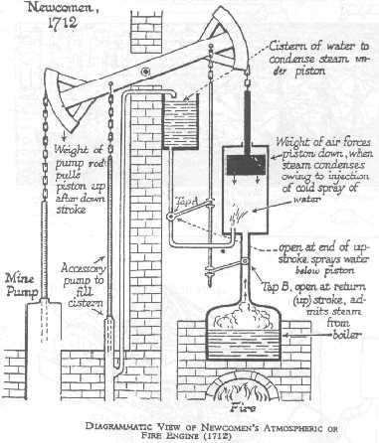 Question 5: Circle the part of the Newcomen steam engine that behaves like the plunger and the part that behaves like the cylinder.

Question 6: Use what you know about the motion of particles and states of matter to reason out what Watt discovered: why would heating a piston full of liquid water be less efficient than heating a piston full of steam?

________________________________________________________________________________________________________________________________________________________________
________________________________________________________________________________

The following photographs are of the oldest surviving Newcomen engine. This photograph, taken in the 1880s, shows the engine as it was installed.  Question 4: Circle the part of the steam engine that behaves like a cylinder in a cooled and/or heated syringe. | 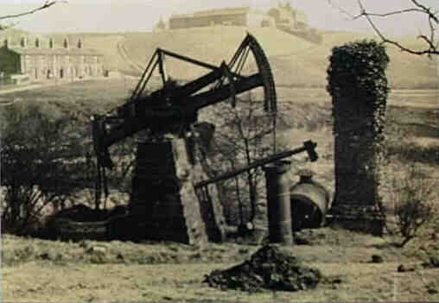

Activity 9 – Homework

Other uses of the steam engine that used the heated/cooled syringe pressure principle, include well known examples such as steam locomotive trains, and steamships These devices, used a bar to hook the moving plunger to a wheel.  Question 4: Circle the part of the steam engine that behaves like a cooled and/or heated syringe. | 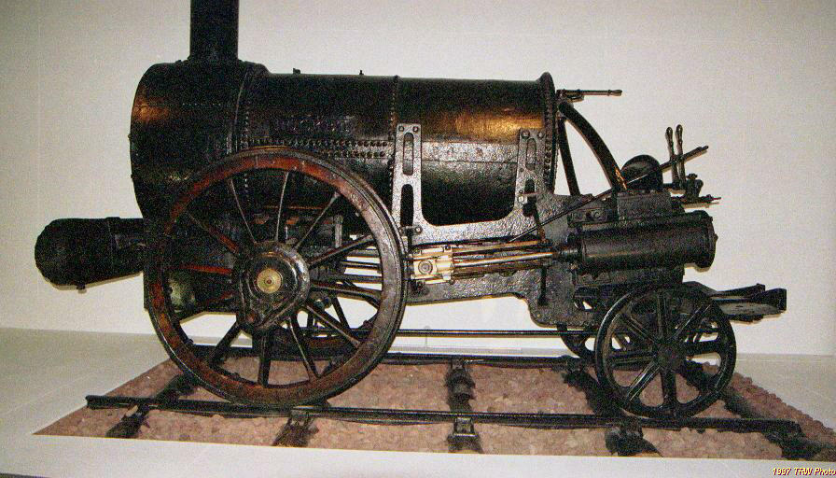
These days we rarely find steam engines in vehicles and machines. The thirty seconds or so required to develop enough pressure in a steam engine by heating water vapor with burning wood or coal, made steam less favored for automobiles and other applications. Instead, internal combustion engines are use to achieve the same type effect more quickly (heating up gas to make pressure from rapid combustion of fuel).
We will investigate combustion (the burning of fuels) further in the next chapter when you investigate chemical reactions.  Early propeller airplanes used internal combustion engines similar to car engines. These airplane and car engines have clearly visible cylinders for the pistons sticking out of the sides of the engine. To the right is photo of the Liberty V8 engine used in early airplanes (modern automobile engines usually have 4, 6, or 8 cylinders and pistons)  Question 4: Circle the part of this engine that behaves like a cooled and/or heated syringe. | 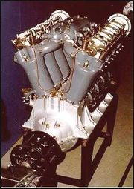

At the start of this chapter, you observed three air pressure related phenomena. You pressed down on a sealed syringe, you studied the inflation of a bike tire with a bike pump, and you observed a heated soda can collapse in water.

The activities you completed in this unit have give you a sense of what is happening to gas particle movement and interactions when the number of particles, temperature of the gas, and container volume are changed. These changes can account for changes in air pressure and changes in air pressure can account for the phenomena you observed at the start of the unit.

Activity 10 - Ideal Gas Applications

Review the phenomena you observed in activity 1 and discuss your ideas and answers to these questions with your classmates.
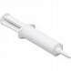 | Object 1 - capped syringe

Question 1: Why can’t you push the plunger in all the way to the bottom of the syringe when it is capped and filled with air?
________________________________________________________________________________________________________________________________________________________________________________________________________________________________________________________________________________________________________________________________

Question 2: Why does pushing in the volume change the pressure in the syringe?

________________________________________________________________________________________________________________________________________________________________________________________________________________________________________________________________________________________________________________________________

Question 3: If you pull the syringe out, it snaps back. Explain why this happens. In you explain, describe the gas particles are doing inside the syringe and on the outside of the syringe?

________________________________________________________________________________________________________________________________________________________________________________________________________________________________________________________________________________________________________________________________
________________________________________________________________________________________________________________________________________________________________________________________________________________________________________________________________________________________________________________________________

Activity 10 - Ideal Gas Applications

 | Object 2 – bike pump and tire

Question 4: When you press down on the air pump, where do the air particles inside of it go?

________________________________________________________________________________________________________________________________________________________________________________________________________________________________________________________________________________________________________________________________

Question 5: When you press down on the air pump, why does the air pressure inside the bike tire increase?

________________________________________________________________________________________________________________________________________________________________________________________________________________________________________________________________________________________________________________________________

Question 6: Why does a bike tire hold its general shape even when you sit on it ?

________________________________________________________________________________________________________________________________________________________________________________________________________________________________________________________________________________________________________________________________
________________________________________________________________________________________________________________________________________________________________________________________________________________________________________________________________________________________________________________________________

Activity 10 - Ideal Gas Applications

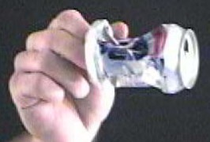 | Object 3– Collapsing Soda Can  To explain why the soda can collapses is important to first identify the five main stages that the soda can goes through before making it collapse. Once you apply what you understand about gas particles to each stage, you will be able to predict the type of qualitative changes that occurring in particle number, temperature, pressure, and volume.

Stage One | Stage Two | Stage Three | Stage Four | Stage Five
Start with an open can, filled with air and a drop or two of water at room temperature. | Heat the can, with open end upward, letting steam and other gases escape. | Flip the can upside down into water, trapping the gas in the can with a layer of water. | The walls are cooled. | The can collapses.

In Stage One:  Temperature of the gas inside the can is: at room temperature  Pressure of the gas inside the can is: the same as the surrounding air.  Volume of the gas container: _a standard soda can__  Number of molecules of gas in the container:  unknown but constant at first  (and is the same density as the air outside the container) | A model of the air inside and outside the can:  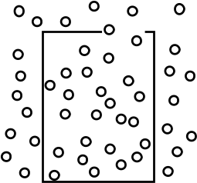

In Stage Two:  Temperature of the gas inside the can compared to stage one:  a) has increased b) has decreased c) hasn’t changed  Pressure of the gas inside the can compared to stage one:  a) has increased b) has decreased c) hasn’t changed  Volume of the gas container compared to stage one:  a) has increased b) has decreased c) hasn’t changed  Number of molecule of gas in the container compared to stage one:  a) has increased b) has decreased c) hasn’t changed | Draw a model of the air inside and outside the soda can:

In Stage Three:  Temperature of the gas inside the can compared to stage two:  a) has increased b) has decreased c) hasn’t changed  Pressure of the gas inside the can compared to stage two:  a) has increased b) has decreased c) hasn’t changed  Volume of the gas container compared to stage two:  a) has increased b) has decreased c) hasn’t changed  Number of molecule of gas in the container compared to stage two:  a) has increased b) has decreased c) hasn’t changed | Draw a model of the air inside and outside the soda can:

Activity 10 - Ideal Gas Applications

Stage One | Stage Two | Stage Three | Stage Four | Stage Five
Start with an open can, filled with air and a drop or two of water at room temperature. | Heat the can, with open end upward, letting steam and other gases escape. | Flip the can upside down into water, trapping the gas in the can with a layer of water. | The walls are cooled. | The can collapses.

In Stage Four:  Temperature of the gas inside the can compared to stage three:  a) has increased b) has decreased c) hasn’t changed  Pressure of the gas inside the can compared to stage three:  a) has increased b) has decreased c) hasn’t changed  Volume of the gas container compared to stage three:  a) has increased b) has decreased c) hasn’t changed  Number of molecule of gas in the container compared to stage three:  a) has increased b) has decreased c) hasn’t changed | Draw a model of the air inside and outside the soda can:

In Stage Five:  Temperature of the gas inside the can compared to stage four:  a) has increased b) has decreased c) hasn’t changed  Pressure of the gas inside the can compared to stage four:  a) has increased b) has decreased c) hasn’t changed  Volume of the gas container compared to stage four:  a) has increased b) has decreased c) hasn’t changed  Number of molecule of gas in the container compared to stage four:  a) has increased b) has decreased c) hasn’t changed | Draw a model of the air inside and outside the soda can:

Activity 10 - Ideal Gas Applications

In order to explain why the soda can collapses it is important to connect your quantitative predictions for the can to some quantitative predictions. To do this you will apply the ideal gas law to calculate the changes that are occurring at each of the five main stages that the soda can goes through before it collapses. Understanding what is happening to the number of gas particles in the can, the temperature of the gas, and the pressure of the gas inside and outside the can, will help you explain why it collapses.

Fill out the numbers that you know and don’t change between each stage and then use
R = 8.2057 x 10⁻² L▪atm▪moles⁻¹▪K⁻¹ and the ideal gas law to calculate what changes.

In Stage One:
Temperature of the gas inside the can is approximately: _________ K
Pressure of the gas inside the can is: ________atm.
Volume of the gas container: _____ oz. and converted to _______ L.
(1 oz. = 0.0295 L)
Calculate the number of moles of gas in the container: ____________

In Stage Two:
Temperature of the gas inside the can is around boiling pt. of water: _________ K
Pressure of the gas inside the can is: ________atm.
Volume of the gas container: _______ L.
Calculate the number of moles of gas in the container at this temp: ____________

In Stage Three:
Temperature of the gas inside the can is around boiling pt. of water: _________ K
Pressure of the gas inside the can is: ________atm.
Volume of the gas container: _______ L.
Number of moles of gas in the container at this temp: ____________

In Stage Four:
Temperature of the gas drops (assume to the temperature of the ice bath): _______ K
Calculate the pressure of the gas inside the can is: ________atm.
Volume of the gas container (not crushed yet): _______ L.
The number of moles of gas in the container at this temp: ____________

In Stage Five: (use R = 8.2057 x 10⁻² L▪atm▪moles⁻¹▪ K⁻¹ )
Temperature of the gas inside the can:_______ K
Pressure of gas inside can is now equal to gas outside the can: ________atm.
Calculate the volume of the gas container (crushed) _______ L.
The number of moles of gas in the container at this temp: ____________

Activity 10 - Ideal Gas Applications

Thinking about the separate stages that a system goes through, can help you reason about the changes that occur in the variables at each stable system state. A stable system state is a simply a stage of a physical system in physics or chemistry that is in a stable phase, form, or composition. In the crushed can situation, there were five stable system states that you considered. Though the can goes through many additional changes between stable system states, it was useful to think of the important “snapshots” in time, when the system is at equilibrium or when nothing noticeable or nothing important is changing from one brief instant to the next. Eventually when a noticeable or important change occurs that will brings the system to a new system state. Try to think of system states as points in time when the system variables are relatively stable.

You are going to use the idea of states to solve some problems related to the ideal gas law.

Example Problem 2: A hydrogen gas thermometer (a thermometer that is filled with gas, instead of liquid and which uses volume of the gas to determine the temperature) is used in this problem to measure the temperature of chlorine. Hydrogen gas would be considered an ideal gas in this problem. The hydrogen gas is found to have a volume of 100.0 cm³ (inside the thermometer) when placed in an ice-water bath at 0°C. When the same thermometer is immersed in boiling liquid chlorine, the volume of hydrogen at the same pressure is found to be 87.2 cm³. What is the temperature of the boiling point of chlorine?

In this problem there are clear stable system states. One system state is when the thermometer is in the ice-water bath. The second system state is when the thermometer is in boiling liquid chlorine. See the next page for example solutions.

Activity 10 - Ideal Gas Applications

Example Problem 2: A hydrogen gas thermometer is found to have a volume of 100.0 cm³ when placed in an ice-water bath at 0°C. When the same thermometer is immersed in boiling liquid chlorine, the volume of hydrogen at the same pressure is found to be 87.2 cm³. What is the temperature of the boiling point of chlorine
Unit conversion: convert 0°C into 273 K
--------------------------------------------------------------------------------------------------------
One solution – use reasoning about particle behavior and linear effects:
At first the volume is 100.0 cm³ ,then the volume changes to 87.2 cm³ This volume decrease should cause an increase in pressure, but it doesn’t (it says the pressure is staying the same). Something else must cancel the effect of increasing the frequency of wall hits from the decrease in volume. It is a temperature change that causes the volume change. The temperature at first is 273°K. The temperature must then decrease so as to cause no net pressure change. The volume decreased to .872 times its original value, therefore the temperature must decrease to .872 times its original value (.872 ▪ 273 K = 238 K )
--------------------------------------------------------------------------------------------------------
Another solution – use symbolic manipulation of the ideal gas law in the first system state
Unit conversation: convert 100.0 cm³ into 100.0 ml into 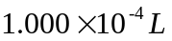
convert 87.2 cm³ into 87.2 ml into 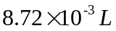
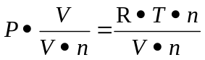
[what we don’t know] 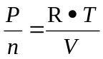 [what we know]
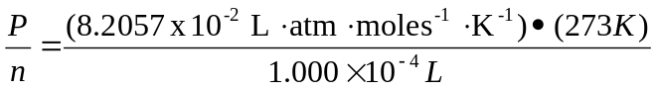
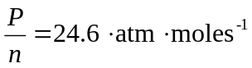
Now knowing this, we can use the equation again to find the new at the second state
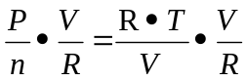
[what we know] 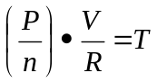 [what we don’t know]
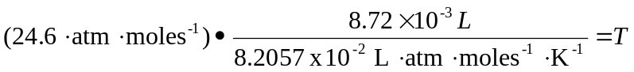
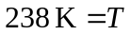

Activity 10 - Homework

Question 1 Imagine are now wearing scuba gear and swimming under water at a depth of 66.0 ft., where the pressure on your body is much higher than on land. To compensate, you are breathing air at 3.00 atm and your lung volume is 10.0 L. Your scuba gauge indicates that your air supply is low so, to conserve air, you make a terrible and fatal mistake: you hold your breath while you surface. | 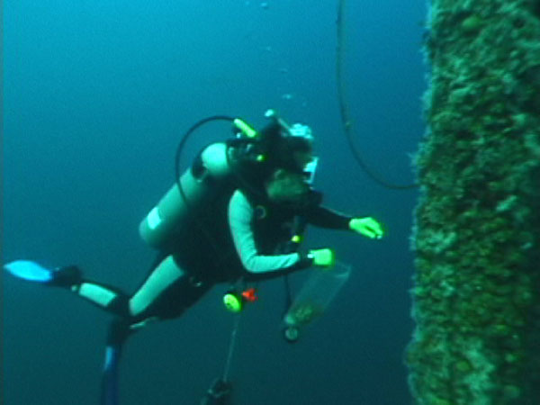

Question 2 Explain or show models of the two important system states in this problem:

Question 3 Why does the diver’s lungs burst? (Provide calculations to support your explanation)

Activity 10 - Homework

Question 3 A gas occupies 1.56 L at 1.00 atm. If the pressure changes to become 3.00 atm, but the temperature and the number of molecules of gas do not change, what will be the volume of this gas change to?

Question 4 Explain or show models of these two system states
(include the appropriate volume change):

