Connected Chemistry - A study of secondary students
using agent-based models to learn Chemistry

Sharona T. Levy, Hyungsin Kim and Uri Wilensky
Center for Connected Learning and Computer-based Modeling
Northwestern University

Paper presented at the 2004 annual meeting of the American Educational Research Association. San Diego, CA.

ABSTRACT

As part of the MAC (Modeling Across the Curriculum) project, we are engaged in iterative software and curriculum design of Connected Chemistry, (Levy, Bruozas & Wilensky, 2003; Stieff & Wilensky, 2003), a modeling and simulation package designed to help secondary and undergraduate students learn chemistry. Connected Chemistry is implemented in the NetLogo (Wilensky, 1999) agent-based modeling environment and enables students to come to see observed macro- level chemical phenomena as resultant from the interactions (on a micro- and submicro- level) of many individual "agents". This emergent perspective is especially appropriate to the study of chemistry, as processes such as melting and evaporation and the concepts of pressure and temperature result from molecular interactions, which students cannot observe directly. The interactions between multitudes of molecules on the atomic level give rise to macro-level phenomena.
Over the past two years, we have conducted research on high school and undergraduate students learning with Connected Chemistry. In this paper, we report on secondary chemistry students engaged with a scripted Connected Chemistry activity, using two levels of scaffolding ("high" and "low") in the computerized scripts. The topic of these Connected Chemistry model-based scripts is ideal gases. A particular topic addressed in the script is the relationship between the behavior of (a changeable number of) particles in a rigid box and the total pressure that they exert.
An interview protocol was developed, piloted with a few students, and successively refined, making sure that two variables could be tested: content knowledge and model exploration. The protocol included a pre-test and post-test, two intermediate interviews and observation categories. In this study, which is the first of a series of studies, two 10-student groups were matched for ability and gender. One group received the high scaffold scripts and the other group received the low scaffold scripts}. Each student was interviewed as they engaged with the Connected Chemistry script. The activity and interviews lasted 60-70 minutes. In addition to the videotaped interviews, data included students' written responses to script prompts during the activity, interviews before and after the intervention, field-notes, as well as observation of their manipulation of the model. Reliability was enhanced by triangulating among the multiple sources of information.
Prior to their interaction with Connected Chemistry, 84% of the students described gas-in-a-box phenomena only in macroscopic terms. After interacting with the Connected Chemistry curriculum, 85% of the students employed micro-level interactions in conjunction with the macro-level phenomena. A correct description of the relationship between the number of particles and the pressure at the macro-level increased from 75% to 100%. No differences in learning gains were found between students who were guided by the two levels of scaffolding. Differences were found in the amount of time spent exploring the models, but not in the number of model variable changes. We provide a preliminary analysis of the lack of marked difference between the students in the different conditions and present criteria for effective scripts to be used in chemistry classrooms.

1.0 INTRODUCTION

A body of science education literature points to student’s misunderstandings of the gaseous phase of matter (Lin & Cheng, 2000; Maz & Perez, 1987).

Levels confusion about gases
Some of these misunderstandings can be related to what Wilensky and Resnick call “levels confusion”, where the properties of, say, the macro-level are incorrectly ascribed to the micro-level. The macroscopic properties of gases are easier to experience and perceive, such as when a kettle boils or a coke bottle produces a hiss when it’s opened. However, the microscopic particles that are moving, colliding and bouncing off the walls are invisible. The literature reports a variety of alternative notions about gases such as ordered packing and weightlessness. Wilensky & Resnick (1999) have described a “levels confusion” which is commonly found in learners’ reasoning across a variety of different contexts. For example, they describe how, in explorations of models of slime-mold cells, students reasoned about the process by which the cells aggregate to form clusters, seemingly new entities. They found that many students as well as researchers failed in recognizing the distinctiveness of the two levels of description of the slime mold, the micro- level of the individual cells and the macro- level of aggregated slime entities.. When the modeler provides the slime-mold cells with more “noses”, students predicted that the clusters of cells would be fewer and larger. In fact, they gather into more and smaller clusters. Wilensky and Resnick attribute this prediction to explanations that assign intentionality to the individual cells, assuming they want to form clusters, as the macro-level actually does. In fact, the cells follow pheromone gradients and a better sense of smell emerges to greater “stickiness” allowing smaller numbers of cells to cluster stably, and a better ability to find new groups, as the sense of smell allows a greater detection angle. This ascription of group-level results, clustering, to the intentions and goals of the individual cells is an illustration of a ‘”levels confusion”. Lin and Cheng (2000) describe high-school students’ failures in understanding Kinetic Molecular Theory as it applies to gases: molecules are pushed down by atmospheric pressure, molecules stay away from heat and molecules expand when they are heated. All three can be related to our macroscopic daily experiences: our gravitation towards the earth, boiling water rising out of a pot and macroscopic expansion upon heating. Mas and Perez (1987) have found that high-school students regard gases as weight-less, reasoning from the macroscopic behavior that gases rise, and therefore cannot have weight. Similar problems have been reported in a variety of scientific domains, such as genetics (Marbach-Ad & Stavy, 2000) and basic electricity concepts (Frederiksen, White & Gutwill, 1999).

Conceptual and algorithmic understandings
The learning research community has recognized the disconnect between conceptual and algorithmic understandings of Chemistry (e.g., Stieff & Wilensky, 2003; Niaz & Robinson, 1992; Kozma et al, 1990). For example, Berg and Treagust (1993) point to the minimal use of qualitative relationships regarding teaching the gas laws both in a variety of textbooks they analyzed and in teaching approaches in schools. Students may be capable of solving problems that involve the procedures commonly taught in science classes. However, they do not necessarily do as well when approaching a similar problem that requires more qualitative, or conceptual reasoning.

The “Connected Chemistry” curriculum
A fruitful way of approaching the problem of bridging the conceptual and symbolic forms of representing chemical phenomena, is the use of computer models that employ multiple representations and afford their connection (see 4M:Chem, Kozma et al, 1996). Frederiksen, White & Gutwill (1999) have used a variety of models, in computer simulations, to help students connect the different levels that can be used to describe basic electricity: a particle model, an aggregate model and an algebraic model. The work reported here builds upon this previous work, but is designed to enable additional freedom and exploratory flexibility, such as changing the model on the fly while it is running. This affordance for students to connect the observed phenomena with the mechanism or rules underlying the model enhances the credibility of the model as truly computational or ‘real-time’, and not a prepared “movie” selected by the programmers and developers.
NetLogo is a general-purpose programming language and modeling tool for exploring multi-agent complex systems. It is used to simulate a wide variety of phenomena, ranging from social systems (segregation of party-goers in the Party model, (Wilensky, 1997), biological systems (wolves predating on sheep in the Wolf-sheep model, (Wilensky, 1997), cellular automata and many more. A common theme in all these models is the emergent perspective. Individual agents are provided with simple rules. The collective behavior emerges out of the parallel operation of many such agents in the model. This platform enables users to construct complex dynamic phenomena and the exploration of how such phenomena “emerge” from micro- level behavior or “rules”.
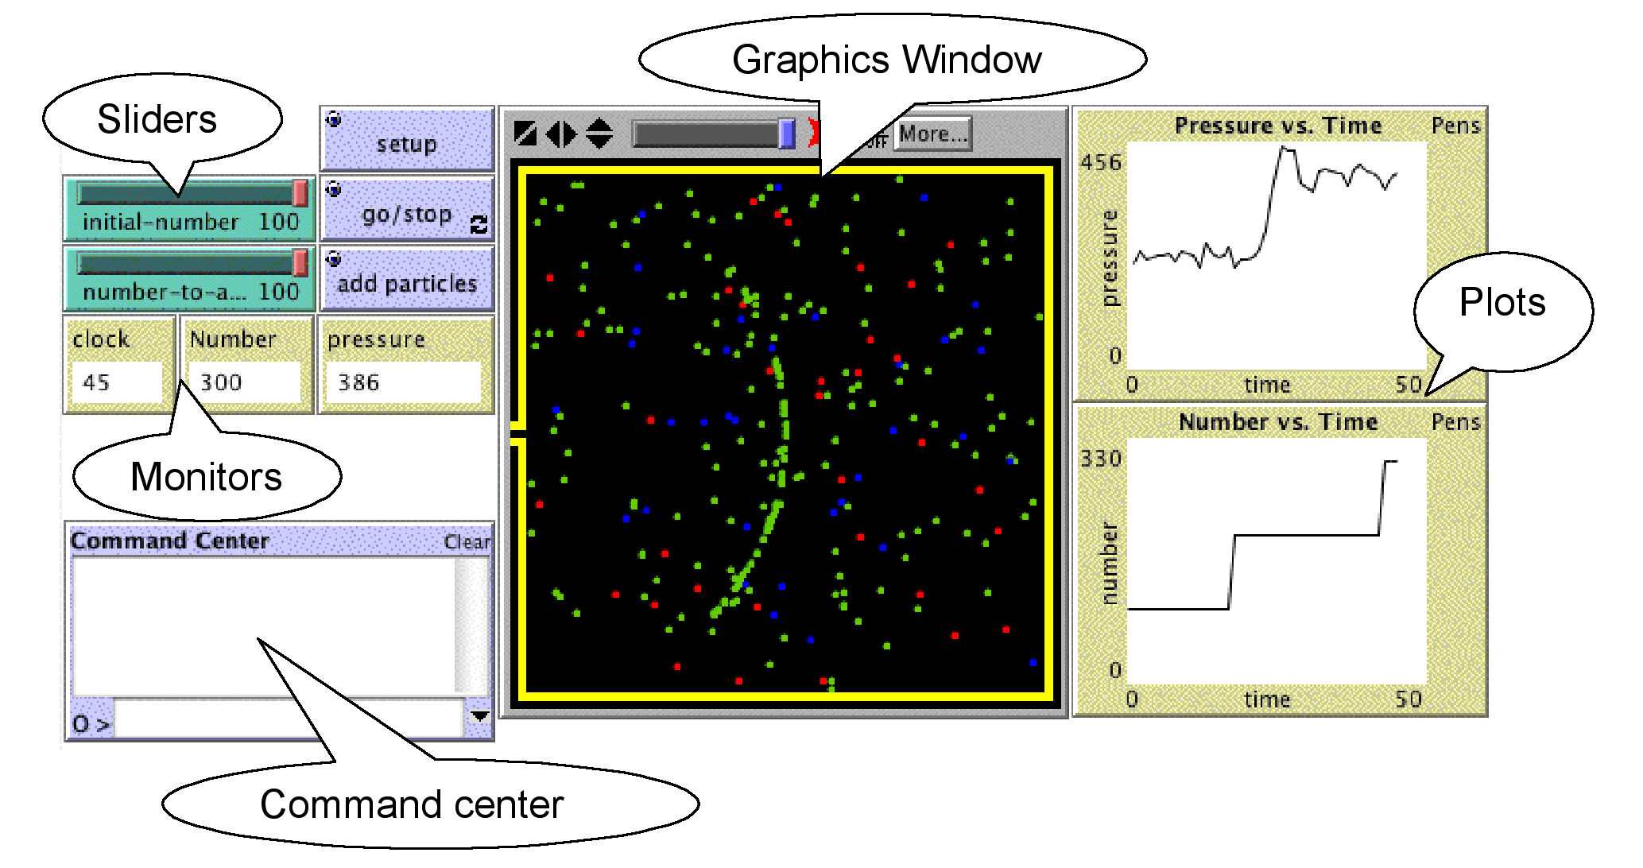
Figure 1: The NetLogo Modeling Environment Interface

In particular, we find the use of agent-based modeling tools powerful for learning about a variety of topics in chemistry. In chemistry we are challenged to move back and forth between multiple representations and levels of description. At the macroscopic level, we can sense and measure observable behaviors of matter. However, at the microscopic level, we can only hypothesize, imagine and try to visualize the behaviors of individual molecules. This kind of ‘emergent’ reasoning can contribute to understanding how a micro-level description of the particles or the molecules can transform through their concurrent behaviors to the global patterns, which we can sense.
At the Center for Connected Learning and Computer-Based Modeling (aka CCL), we collaborate as part of the MAC (Modeling Across the Curriculum) project in developing a strand of the “Connected Chemistry” curriculum (Levy, Bruozas & Wilensky, 2003) using agent-based NetLogo models that are embedded into Pedagogica scripts. In these learning environments we investigate the gap between micro- and macro-levels. We open the way for our students, not only to visualize the particles, but also to reason through the levels, bridging and connecting them through the concept of emergence. A central feature of the curriculum involves not only using models but also thinking through the process of constructing a model. The models are presented with their assumptions and approximations, starting out with the fewest possible rules. Gradually, particles are added, and the rules governing their behaviors are introduced one-by-one. Students are then encouraged to compare the models to their real world observations.

The goals of our curriculum development in the MAC project are the following:
Embedding NetLogo models into novel science curriculum, in a way that will..
- ..provoke and facilitate the distinction and connection between model and real world in science.
- ..challenge and promote a causal understanding of Chemistry concepts within the framework of complex systems.
- ..scaffold reasoning ‘from the molecule up’ by promoting an intimacy with molecular behavior and connecting this with emergent group patterns (micro-macro connections)

The first chapter in the curriculum targets the topics of gas laws and Kinetic Molecular Theory (KMT), as well as understanding the process of modeling. A sequence of six activities is planned to help the students derive the various macroscopic gas laws (number of particles and pressure → KMT → volume and pressure → temperature and pressure → temperature and volume), and end with the complete Ideal Gas Law.

In general, each activity is organized in the following way, based on the above principles:
- Contextualizing with a real-world phenomenon
- Constructing the model from its objects and rules
- Micro-level perspective: exploring particle behavior –
- from qualitative to quantitative understanding.
- Macro-level perspective: exploring the system’s change over time and deriving the gas laws –
- from qualitative to quantitative understanding.
- Comparing model and reality
- Reviewing

The following figure 2 shows a sample screen.
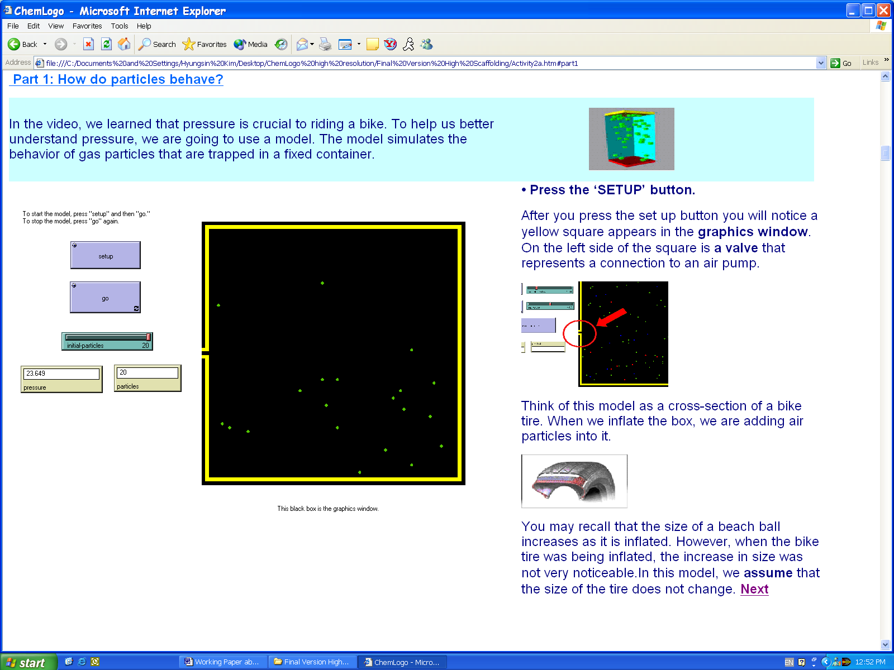
Figure 2: Sample screen from first version of curriculum. The top text connects to a real-world phenomenon in the previous screen. The model is introduced and explained.

Our models afford concurrent viewing of both micro-level behaviors of gas particles and macro-level system properties in a variety of ways.
Slowing down time: In the first activity, which we report on in this paper, the pressure is related to the particles hitting the wall. This requires a distinction between the particle-to-particle collisions and the wall hits. When there are more particles in the box, the rate at which the particles hit the wall increases and pressure rises. The students can observe how a group of particles, which is injected from a hole, moves through the box (see Figure 3 on the left). Only as it hits the opposite wall, does the pressure rise. It then falls as they bounce off the wall and head back. The pressure fluctuates and gradually equilibrates as particles collide with each other, changing direction and speed. Connecting the specific phenomenon of an easily discerned “particle wave” to the pressure, its delay and the equilibration processes touches at the heart of the mechanism that underlies pressure as a group or aggregate phenomenon.

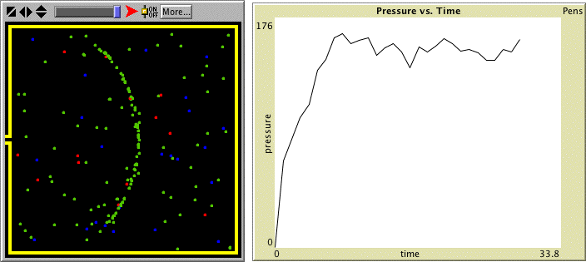 | 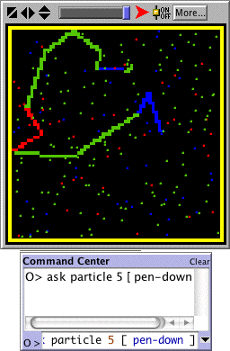
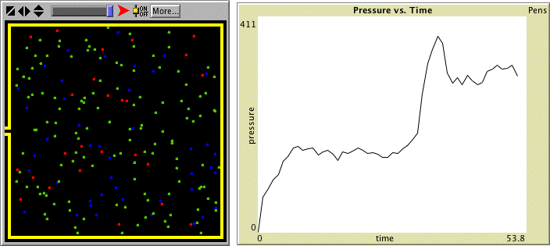
Figure 3: On the left: Pressure increases when particles are added to the box. However, it doesn’t go up at once. Only when the injected particles hit the far wall, does the pressure rise. The system gradually equilibrates through randomization by collisions, stabilizing pressure. On the right: A single particle leaves a trace as it moves about. The colors represent speeds: blue is slow, green is medium, and red and fast.

Leaving a history: In a later version of the curriculum (see above figure on right), a single particle leaves a trace as it moves about a container. When it collides, it changes its direction and perhaps its color (the color represents a speed range – slow, medium, fast). When there are more particles in the box, the more frequent collisions usually cause this traced path to “fold in on itself” and the particle moves about through a smaller two-dimensional space. In this case, many molecules will move through smaller spaces on the inside of the box, colliding frequently with other particles, but not with the wall (other particles that are “stuck” near the wall will hit it many times). On the other hand, the overall rate at which the particles are hitting with the wall increases. The students are asked to resolve this paradox between the micro-level wall hits per particle, and macro-level hits for the whole wall. Co-dependence of the particles is discussed.
Zooming out: Another means we are currently employing to help students bridge the two levels of description involves focusing on “mid-levels”. In another research project (Levy & Wilensky, 2004), we have found that students invent and construct “mid-levels” in explaining and simulating emergent phenomena. These levels were found to cluster around particular numbers for sixth-graders (slightly over three agents in a mid-level, or mid-levels in a group). In one of the models in the curriculum, we “zoom out” to observe only five particles, a “mid-level” which we assume may be the processing limit up to which 11th-grade students can observe and reason about at one time.

The following scheme describes the activity, which was used in the described research. Two versions were prepared to test the effect of scaffolding on the students’ learning and model exploration: high-scaffolding and low-scaffolding.

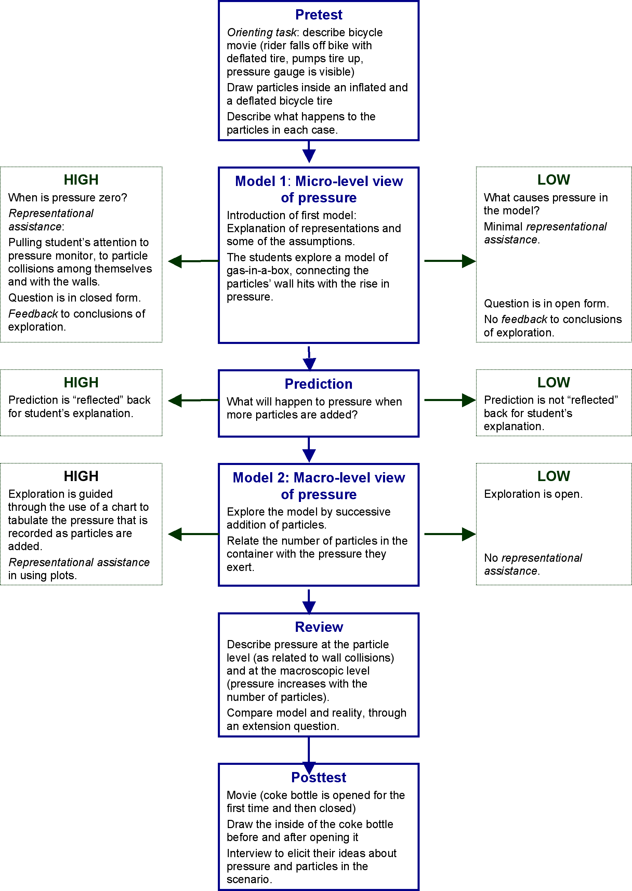
Figure 4: Script that was used in the reported research. Distinctions between the scaffolding in the two conditions are described.
High-scaffolding screens | Low-scaffolding screens
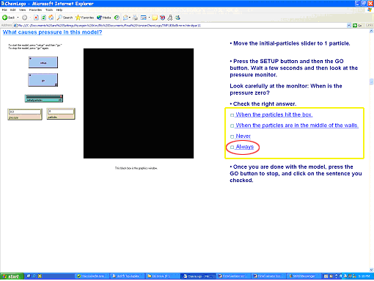 | 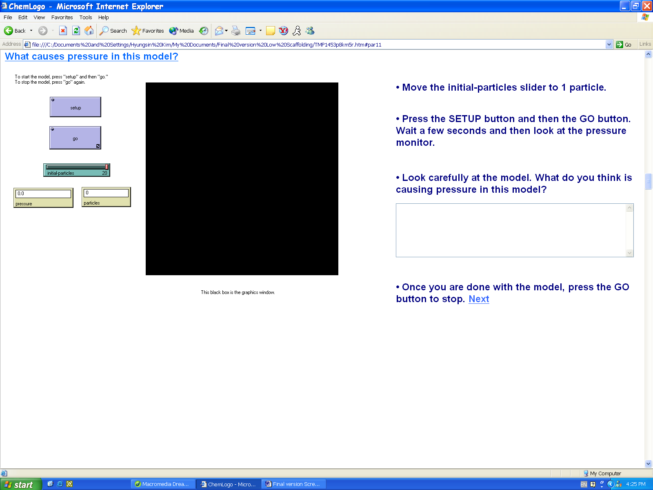
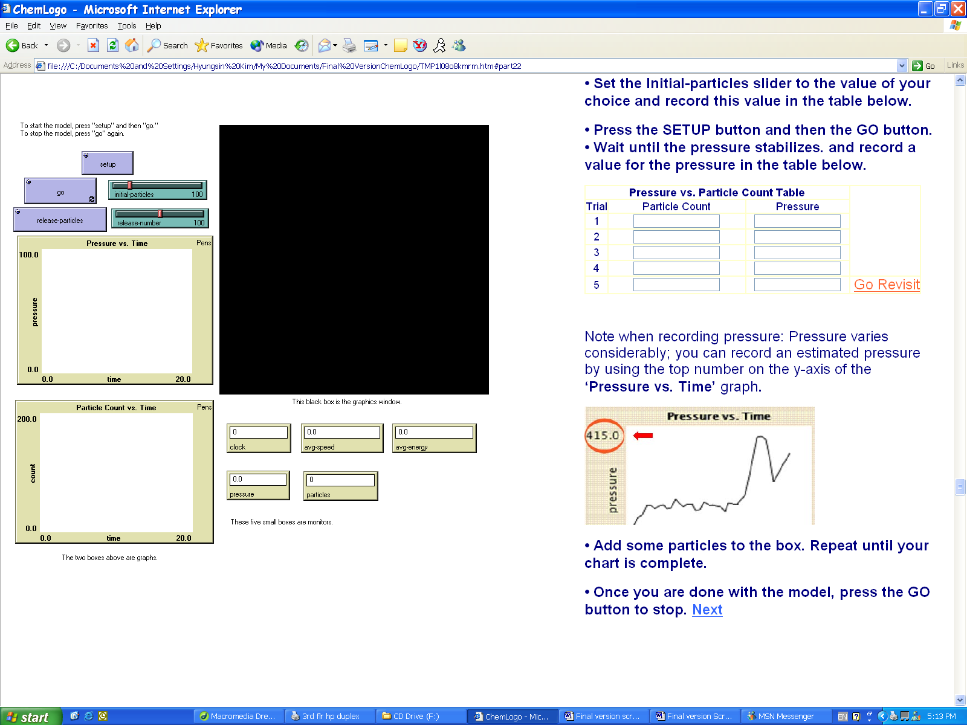 | 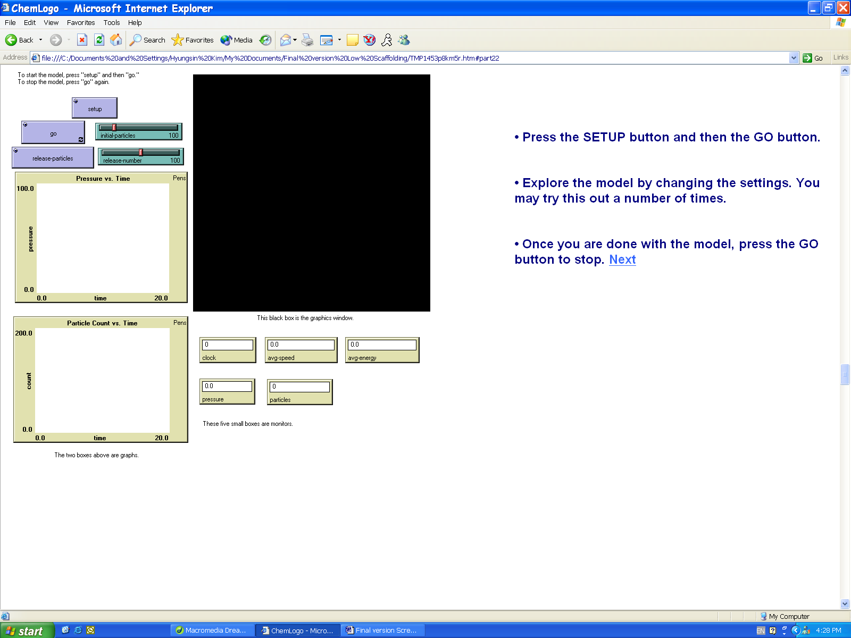
Figure 5: Samples of High- and Low-scaffolding screens in the first version of Connected Chemistry.

The figures above show screens, which were different for the two levels of scaffolding. In the first comparison, the high-scaffolding condition (left) directs the activity to finding out when pressure is zero. In the low-scaffolding condition (right), no such direction is employed. The student is asked to find out what makes pressure change with no further direction. Another difference is in the computer’s responsiveness. In the high-scaffolding condition, the student chooses a conclusion from a multiple-choice and receives feedback that confirms his choice or directs to further activity. No such feedback is provided in the low-scaffolding condition.
In the second set of screens, we see the guidance provided when the students are investigating the relationship between the number of particles and pressure. In the high-scaffolding condition (left), a table with five rows, into which the students record their data is provided. This frames their activity. In the low-scaffolding condition, no such table is provided. The students are asked to find out how the number of particles is related to pressure.

Scaffolding students’ exploration
Our project involves the use of models that are embedded in supporting scripts. Different levels of support (or “scaffolding”) may be related to the way students learn the content areas and their understanding of modeling. For example, Davis (2003) has found that scaffolding that directs students to reflect upon their inquiry in science more generically produced deeper reflection than scaffolding that directs students in more specific ways. This was related to deeper understanding regarding the complex projects they were engaged with. We have used a conceptual scheme developed by Gobert (2003) to describe and segment different forms of scaffolding. Their scheme includes the following kinds of scaffolding: Advance- and post-organizers, orienting tasks, representational assistance, support for pieces of the model, model-based reasoning supports and feedback. We have employed this framework to describe our scaffolded scripts.

Thus, our research questions are the following:
- What content learning takes place while using Connected Chemistry models and scripts?
- How can we characterize students’ exploration of models?
- What is the relationship between content learning and model exploration
- What is the relationship between content learning and the level of scaffolding offered in the script?

METHOD

The first study involved a single intervention and interview, aimed at defining and refining some of the design and scaffolding questions and measures. One test activity was developed, with two versions: higher and lower scaffolding and support. It uses NetLogo models that are related to gas laws, which are embedded in an html script that poses tasks, asks questions and directs the students in their activity.
An interview protocol was developed, piloted with 3 students, refined and changed, until the time-frame was appropriate, making sure that the following could be tested: content knowledge (pressure, macroscopic and microscopic perspectives, transfer) and modeling skills. The protocol included a pretest and posttest, two intermediate interviews and observation categories. The students were asked to point to the place on the screen that they were looking at while exploring the models. The scripts the students completed while going through the activity are a second source of data. The sessions were videotaped, with the camera aimed mainly at the computer in order to record the conversations that were transcribed and follow the students’ activities in exploring the models. Field-notes were written into a template by the observer. Reliability was enhanced by intersecting multiple sources of information (interviews, written scripts, drawings, field notes).

Subjects
We worked with 20 11th-grade students from a Chicago Public School, with 88% who receive free or reduced lunch, mainly Hispanic and African-American.
The teacher rated the students’ academic success on a 3-point scale, and then helped us select two matched samples, that would represent both genders equally, as well as the class distributions of academic success. One group used the high-scaffolding software, the other group used the low-scaffolding software.

Procedure
We worked with the students individually in the teachers’ work-room during 60-70 minutes. A video camera was pointed at the screen, and an interviewer sat by the student. An additional researcher facilitated the activities and took notes (see figure 6).

Computer

Interviewer
Researcher
Student

Camera

Figure 6: Experimental Layout

Analysis
Multiple sources of data were grouped together on the interview timeline. All pre-modeling data and post-modeling data were combined and compared for consistency. A coding scheme was developed.
We compare the students’ understanding of pressure prior to modeling and after the activity. These understandings are grouped by scaffolding level.
The videotapes were coded for model operation, variable changes and model runs. These were analyzed as a group, and separately for the different levels of scaffolding.

RESULTS

We present the results in two parts: (1) Content knowledge (pre- and post-, transfer, scaffolding); (2) Exploring models (content knowledge, scaffolding).

Content knowledge

The students’ expressed ideas were collected through interviews (pre-test, post-test), drawings and the scripts they wrote while engaged in the activity itself. We then combined this data to provide a richer source, in the beginning and at the end of the activity.
We describe the students’ understanding of pressure in macroscopic and microscopic terms. The students’ ability in transferring their new knowledge to unfamiliar contexts is presented as well.

Understanding of pressure: macro and micro perspectives
The macroscopic relationship we targeted in this activity was the qualitative connection between the number of particles and pressure in a rigid box; volume and temperature are constant.
The microscopic perspective regarding this relationship involves the particles’ collisions and wall hits. When there are more particles, they collide more often, and change their speed and direction. As they collide more often, the collisions are ‘relayed’ to the wall as well, and the rate at which the wall is hit increases.
Pressure is related to the rate at which the particles hit the wall. Thus the critical separation is between particle-to-particle collisions and wall hits.
We noted whether or not the students described the macro-level and macro-level perspectives, and whether these descriptions were correct. Students’ descriptions in the interviews, drawings and scripts were coded in the following way:

 | Macro-level | Micro-level
Correct | As the number of particles increases, pressure increases. | As the number of particles increases, the rate of collisions among particles increases.
Incorrect | As the number of particles increases, pressure stays the same or decreases. | When the number of particles increases, their speed decreases/increases, the particles expand, the particles are packed.
Table 1: Correct and incorrect understanding of pressure and particle behavior. Examples are below.

Let’s observe the writing of one student as the script evolves:

- Bike movie (introduction): “The pressure in the bike was lost so he tried to fill it back in with the pump he had.”
- First model: “the air particles in the tire got tighter… they’re moving around and some of them are even colliding.”
- After second model: “I think that as the pressure builds up there are more collisions… I said that the pressure increases because the pressure builds up and I’m guessing that’s what causes the tire to get harder and tighter.”

Note how a (1) purely macroscopic description in terms of “pressure” being added and removed from the bicycle tire, evolves into (2) noticing collisions at the first stage, later (3) connecting the collisions to pressure and then back to inflating the bicycle tire.

We provide a variety of examples to demonstrate our coding.

Macro, no Micro
“When you inflate the tire more particles are going to go into the tire. The more you inflate the more particles get into the tire. If you get more particles the pressure goes up causing the tire to inflate.” (quote from script)
The following drawing of a deflated and inflated tire, does not include the air particles. The volume increases upon inflation but no microscopic information is available.
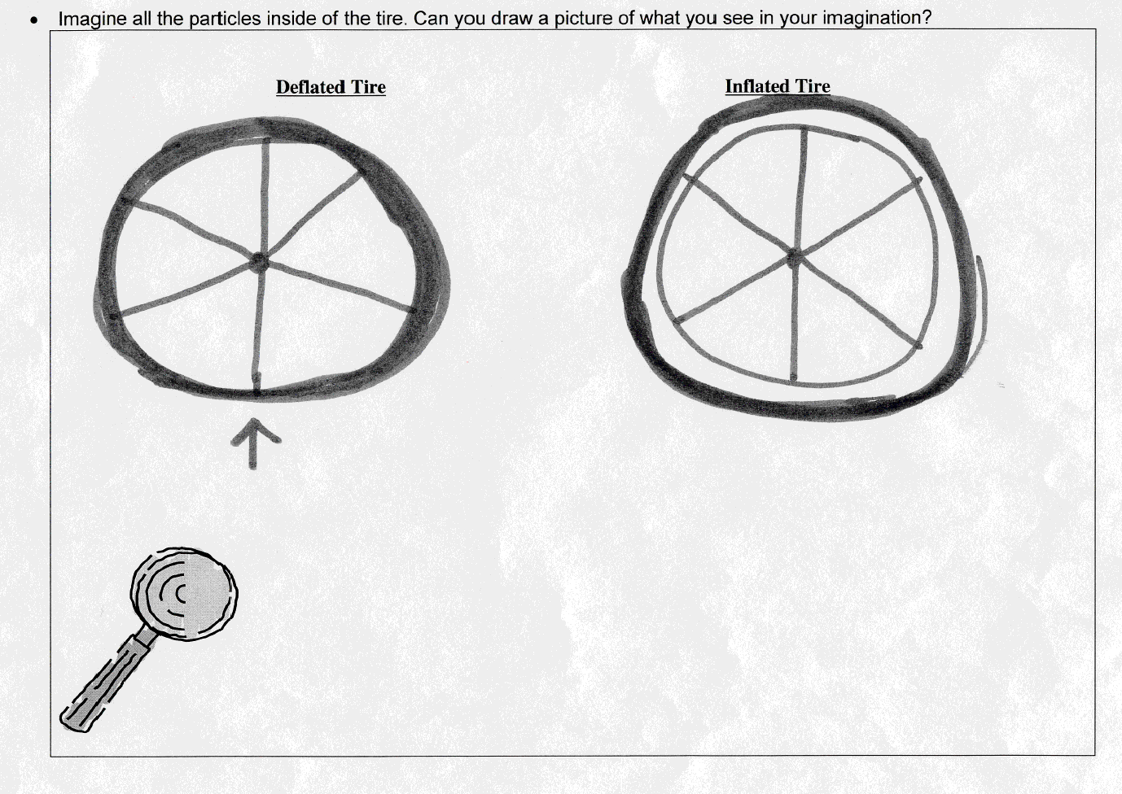

Macro correct, Micro incorrect
“More particles are going to have less room to move freely to, and more and more pressure is going to built inside the tire. More particles are going to be in the tire. The particles are also going to be really packed together.” [quote from the script ]
While this student connects the increasing number of particles to the rise in pressure, in her view, this results from packing at the micro-level. The fact that the size of gas particles is very small with respect to their container is not understood, nor the constant motion of the gas particles. This packing was viewed as the main contribution to increasing pressure at the macro-level.
“The model has changed my understanding of pressure in many ways. First I find out that when there is more particles there is also more pressure. And that when there is more pressure particles move more faster than if there was less particles. So basically I learned a lot about pressure that I didn’t know before.” [ quote from the script ]
In this student’s eyes, pressure increases with the number of particles, at the macro-level. However, at the micro-level this is related to the particles’ increase in speed.
In the following drawing, the inflated tire is denser with air particles, and the annotations describe collisions. However, the student also writes that when the particles are closer, they bump into each other more often, increasing their speed, and thus the pressure.
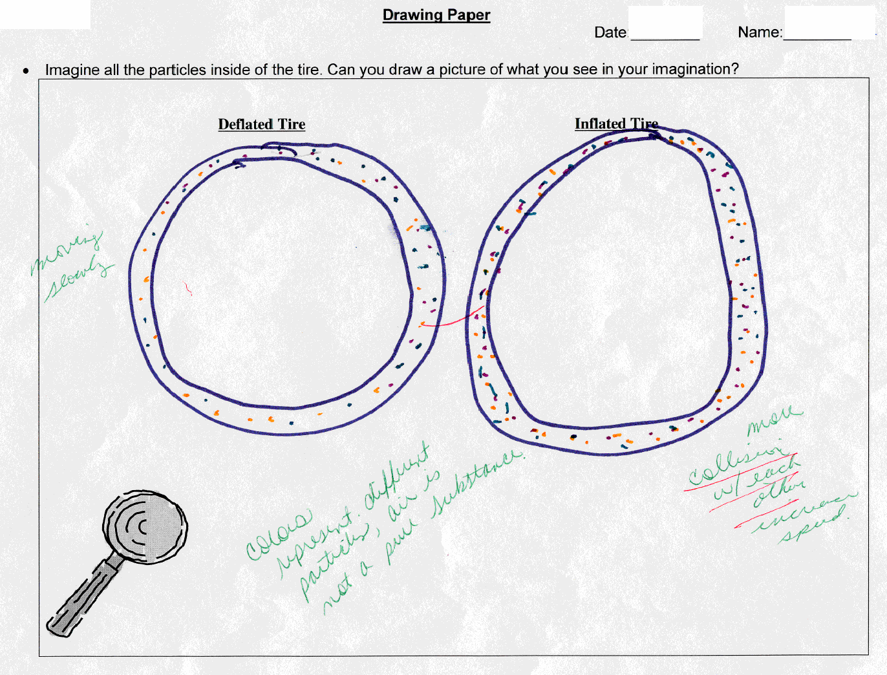

In the following figure, we can see that when there were more particles (on the left) they are packed into a lattice, like a solid. When pressure reduces, that is related to some particles having escaped and order is decreased.
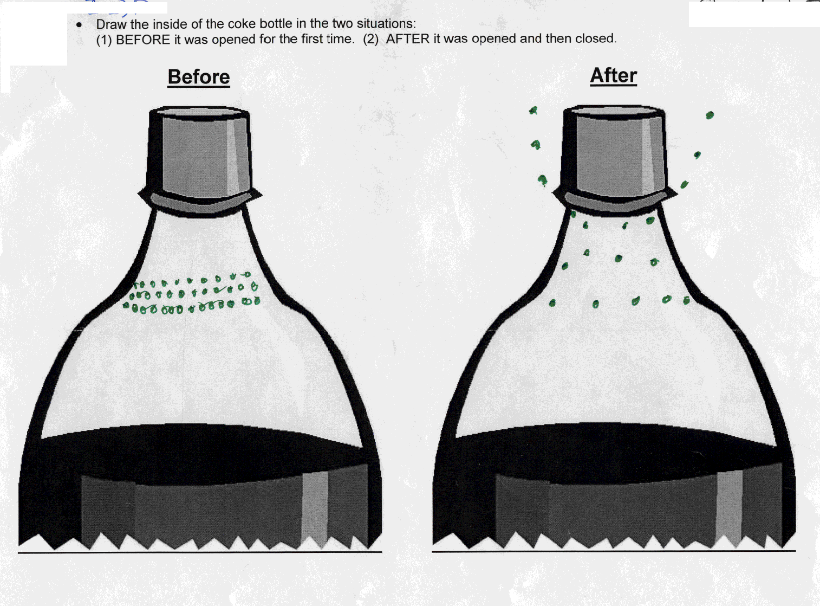

Macro and Micro correct
“The pressure will increase, because the more particles there are, the crowder its going to get and the more their are pushing on one another. The particles will start building tension like in a room full of people – the more there are, the more crowded it gets and after a while one another might start pushing and pulling and then it gets really tense to even be there.” (quote from interview)
This student connects the number of particles to a qualitative sense of density “crowder” in her words, increasing the pushing, or collisions. This is related to ‘tension’ in the analogy she provides in a space crowded with people. Tension is analogized to pressure.
“The number of particles will increase and push each another creating pressure within the tire allowing the pumped air to go all around the tire thus inflating it.” (quote from script)
The number of particles is related to collisions, and these are related to pressure and air, as the tire is inflated.
The following figure illustrates the particles moving about randomly, with the first bottle including more particles.

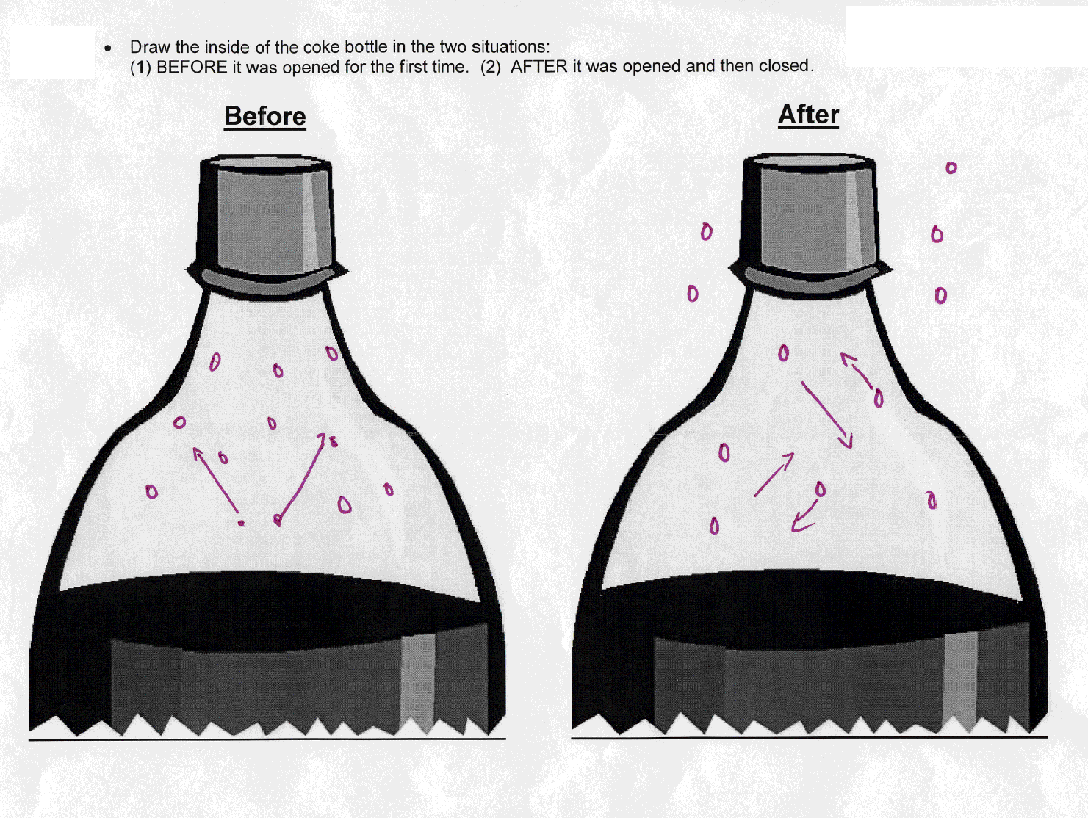

We summarize the results in the following table:

 | Macro and Micro correct | Macro correct, Micro incorrect | Macro correct, no Micro | Macro incorrect, no Micro | Total
Pre-test | 3 (6%) | 2 (10%) | 10 (50%) | 5 (25%) | 20 (100%)
Post-test | 13 (65%) | 4 (8%) | 3 (6%) | 0 (0%) | 20 (100%)
Table 2: Group results regarding understanding of pressure and particle behavior. The values represent the number of students, their proportion (%) is in parentheses.

Prior to the experiment, most of the students understood the qualitative relationship between the number of particles and pressure. At the end, the 25% who did not understand it before the activity, understood it correctly as well.
The major shift is from using only macro-level descriptions to using both macro- and micro-level descriptions. Micro-level particle behaviors were described by only 16% before the experiment. 72% included micro-level descriptions at the end, most of them correct.
The largest increase was in the category of describing both levels correctly: here, we can see a rise from 6% to 65%.

Transfer
At the end of this session, we asked the students to describe the gas in a closed coke bottle, before and after it was opened for the first time. A short video-clip showed the bottle being squeezed in the beginning, opening the bottle (with its typical hiss of escaping gas), closing the bottle, and squeezing it once again. The students were asked to draw the gas in the top part of the bottle above the coke – before and after it was opened. They then explained their pictures and the events that take place.
Among the 20 students, 18 students showed an understanding of the relationship between the number of particles and pressure. The two students who didn’t confused the small bubbles with the sub-microscopic gas particles.

Scaffolding
The post-test results were compared for the students in the two scaffolding conditions. No significant differences were found

To conclude these results:
- A correct understanding of the macroscopic relationship, connecting pressure to the number of particles increased from 75% to 100% through this intervention.
- A large increase was seen in the number of students who demonstrated both description levels: macroscopic relationship and microscopic particle behavior.
- Most of the students could use their new understanding in a problem set in a context that was different from that in the activity.

Exploring models

In this section we look into the ways that the students explored the models, and how it relates to the level of scaffolding. A video-camera captured the students’ screens while they were working, and allowed us to note various features. The three variables that were used to characterize the students’ model exploration (exploration time, number of runs, number of variable changes) were compared for the two levels of scaffolding (high and low scaffolding). Correlations were calculated between the level of scaffolding and these characteristics.
No significant differences were found between the two scaffolding levels for the number of model runs (mean of 11.0, SD 4.0) or the number of variable changes (mean of 10.2, SD 2.6).
A significant difference was found between the two scaffolding levels for the amount of time spent exploring the model: 23.9 minutes, SD = 4.7 for high-scaffolding; 19.7 minutes, SD=4.5 for low-scaffolding. The Spearman’s rho correlation coefficient in this case is 0.52, p=0.019. When the students were provided with less guided exploration instructions, they spent less time exploring the model. The difference in time involved the students in the high-scaffolded condition observing the models, and recording data into a table.
While we don’t discuss the graph in terms of this study, we have used the following data to gauge which models elicited a “busier” exploration.
Figure 7: Number of model runs and variable changes in the different screens, which included NetLogo models.

To summarize:
- The students performed more runs than variable changes: they were testing each set of variables more than once.
- The level of scaffolding was associated only with the amount of time spent running the models. Greater scaffolding was related to the students spending more time exploring the models.
- Given that the students ran a similar number of runs and variable changes, this difference in exploration time is made up mainly of observing the model itself and recording data.

DISCUSSION

We have described our curricular goals and some initial findings with a first version of one activity. The topic of the activity was the relationship between the number of particles in a rigid box and the pressure that they exert on its walls.
We have found that most of the students advanced from a mainly macroscopic understanding of the process of inflating a tire to an understanding that includes the microscopic particle level as well. No differences in content knowledge can be associated with the level of scaffolding.
The most important result from our perspective was the students’ increased attention to the microscopic level. While the macroscopic relationship was understood by most of the students prior to the activity, their main gain was in using multiple levels in their descriptions. This had been our main goal in the curriculum and it was achieved. By providing means of manipulating and exploring a small visible world of simulated particles, we have made it accessible to the students who participated in the activity. They were able to reason about both particles’ behaviors and group patterns when applying their understanding to the phenomenon they had explored (inflating a bicycle tire) and to additional contexts (opening a coke bottle and reducing its pressure). However, it is important to notice that they did not “bridge” between the levels. While they could describe particles and pressure separately, very few students actually connected the two in a fully causal way. Our current curriculum development is focused on a gradual bridging between the two levels, using paradoxes and smaller “chunks” as the students work through the activity.
We make some reservations regarding our conclusions: the sample was small, such that we cannot draw general conclusions. The students exceeded our initial expectations, possibly demonstrating a ceiling effect. As a result, we planned the next set of activities that were tested later in the year 2003, to include more challenging concepts.
We found that whether the students’ activity with the models was directed to a greater or lesser extent, this made no difference in the degree to which they manipulated the model and changed the model variables. This shows us that increasing the “freedom” in exploring models does not detract from the experimental spirit they expressed in the activity. They explored the model just as much as students in a more directed environment. One does not need to close and script their actions, in order to make sure that they are engaged in exploring the models. However, one significant difference was in exploration times. In the more supported environment, the students spent more time exploring the models. This is due mainly to increased times in observing the model as it changes. As such observation skills are crucial to finding patterns and understanding complex phenomena, we have created a number of activities that support students in these very skills. For example, in the latest version, the students are guided into various exploration tools and metrics that help focus on both particle behavior and group patterns.
In the current version, which is currently being programmed, we employ many open-ended questions and activities, so that we may gauge how far we can go. We still employ closed questions at the end of each exploration, so that we make sure all the students achieve an understanding that combines macroscopic and microscopic perspectives.
Our understanding has grown together with that of the students.

Acknowledgements
We thank Hyungsin Kim for her many contributions in constructing the experimental version of the curriculum, participating in the research and its analysis.
This research is funded by NSF IERI grant number 0115699.

REFERENCES

Davis, E.A. (2003). Prompting middle school science students for productive reflection: Generic and directed prompts. The Journal of the Learning Sciencesˆ, 12(1), 91-142.
de Berg, K.C., Treagust, D.F. (1993). The presentation of gas properties in chemistry textbooks and as reported by science teachers. Journal of Research in Science Teaching, 30(8), 871-882.
Freriksen, J.R., White, B.Y. & Gutwill, J. (1999). Dynamic mental models in learning sciences: The importance of constructing derivatiaonal linkages among models. Journal of Research in Science Teaching, 36(7), 806-836.
Gobert, J. (2003). Students' Collaborative Model-Building and Peer Critique On-line. Presented at the National Association for Research in Science Teaching, Philadelphia, PA, March 23-26.
Kozma, R., Russell, J., Jones, T., Marx, N., & Davis, J. (1996). The use of multiple, linked representations to facilitate science understanding. In Vosniadou, S., Glaser, R., DeCorte, E., and Mandl, H. (Eds), International Perspectives on the Psychological Foundations of Technology-Based Learning Environments, Erlbaum, Hillsdale, NJ, 41-60.
Kozma, Russell, J., Johnston, J. and Dershimer, C. (1990). College students’ understanding of chemical equilibrium. A paper presented at the Annual Meeting of the American Educational Researcher Association, Boston, MA.
Levy, S.T. & Wilensky, U. (2004). Inventing a “mid-level” to make ends meet: Reasoning through the levels of complexity. In S. Papert (Discussant) Networking and complexifying the science classroom: Students simulating and making sense of complex systems using the HubNet networked architecture. The annual meeting of the American Educational Research Association, San Diego, CA, April 12 – 16, 2004.
Levy, S.T., Bruozas, M., Wilensky, U. (2003). Connected Chemistry Curriculum 1.0 Evanston, IL. Center for Connected Learning and Computer Based Modeling, Northwestern University. ccl.northwestern.edu /curriculum/chemistry/.
Lin, H-S, Cheng, H-J (2000). The assessment of students and teachers’ understanding of gas laws. Journal of Chemical Education, 77(2), 235-238.
Marbach-Ad, G., Stavy, R. (2000). Students’ cellular and molecular explanations of genetic phenomena. Journal of Biological Education, 34(4), 200-205.
Mas, C.J.F. & Perez, J.H. (1987). Parallels between adolescents’ conceptions of gases and the history of chemistry. Journal of Chemical Education, 64(7), 616-618.
Niaz, M., Robinson, W.R. (1992). From ‘algorithmic mode’ to ‘conceptual gestalt’ in understanding the behavior of gases: An epistemological perspective. Research in Science and Technological Education, 10(1), 53-65.
Niaz, Mansoor (2000). Gas as idealized lattices: A rational reconstruction of students’ understanding of the behavior of gases. Science and Education, 9, 279-287.
Stieff, M. & Wilensky, U. (2003). Connected Chemistry – Incorporating interactive simulations into the chemistry classroom. Journal of Science Education and Teaching, 12(3), 285-302.

